**PRACTICAL JOURNAL**

**M.Sc. (Computer Science)**

**Sem – II**

**Academic Year: 2021 – 22**

**[TPGCSP202]**

**Cloud Computing**

**(Concepts and Design of Web Services)**

**Department of Computer Science,**

**Thakur College of Science and Commerce**

**(Autonomous),**

**Thakur Village, Kandivali (East),**

**Mumbai – 400101**



CERTIFICATE

This is here to certify that Mr. **Prajapati Yash Vasudeo**, Seat Number **022** of M.Sc. Computer Science, has satisfactorily completed the required number of experiments for the subject Cloud Computing (Concepts and Design of Web Services) prescribed by the Thakur College of Science and Commerce (Autonomous) during the academic year 2021– 22.

Date: 20/4/2022

Teacher In-Charge Head of Department

External Examiner College Seal

**Thakur College of Science and Commerce (Autonomous)**

**M.Sc. Part-I (Computer Science), Semester-II**

**Cloud Computing**

**(Concepts and Design of Web Services)**

**[TPGCSP202]**

**Index**

|  |  |  |  |
| --- | --- | --- | --- |
| **Sr. No.** | **Practical Title** | **Date of Conduction** | **Signature of Professor** |
| 1 | Develop Time Server service that returns current time in Java and call it from clients developed in Java, PHP, Android and .NET. |  |  |
| 2 | Develop Web service in Java that returns complex data types (e.g. as List of friends). |  |  |
| 3 | Develop Web service in Java that returns matrix multiplication by Strassen’s algorithm. Two matrices will be entered at run time by client. Server does the  matrix multiplication and returns answer to client. |  |  |
| 4 | Demonstrate CRUD operations with suitable database using SOAP or RESTful Web service. |  |  |
| 5 | Create and configure Virtual Private Cloud using AWS. |  |  |
| 6 | Develop WCF service returning response in JSON type. |  |  |
| 7 | Study and implement Identity and Access Management in AWS. |  |  |
| 8 | Demonstrates how to make basic requests to Amazon DynamoDB including: how to create a DynamoDB table with an LSI and GSI that can be accessed via a  combination of hash keys and range keys.  ● how to add items to a table  ● how to get items from a table  ● how to query items on a table  ● how to scan items from a table using a filter expression  ● how to update items on a table  ● how to get items from a table in a batch  ● how to write items to a table in a batch  ● how to delete a table |  |  |

**Experiment no - 01**

**AIM:** Develop Time Server service that returns current time in JAVA and call it from clients developed in JAVA, PHP, Android and .NET

TimeServer.java

package CCPrac1.Yash022;

import javax.jws.WebService;

import javax.jws.WebMethod;

import javax.jws.soap.SOAPBinding;

import javax.jws.soap.SOAPBinding.Style;

@WebService

@SOAPBinding(style = Style.RPC)

public interface TimeServer {

@WebMethod

String getTimeAsString();

@WebMethod

long getTimeAsElapsed();

}

TimeServerImp.java

package CCPrac1.Yash022;

import java.util.Date;

import javax.jws.WebService;

@WebService(endpointInterface = "CCPrac1.Yash022.TimeServer")

public class TimeServerImpl {

public String getTimeAsString() {

return new Date().toString();

}

public long getTimeAsElapsed() {

return new Date().getTime();

}

}

TimeServerPublisher.java

package CCPrac1.Yash022;

import javax.xml.ws.Endpoint;

public class TimeServerPublisher {

public static void main(String[] args) {

Endpoint.publish("http://127.0.0.1:9876/one?wsdl",new TimeServerImpl());

}

}

TimeClient.java

package CCPrac1.Yash022;

import javax.xml.namespace.QName;

import javax.xml.ws.Service;

import java.net.URL;

class TimeClient {

public static void main(String[] args) throws Exception {

URL url = new URL("http://127.0.0.1:9876/one?wsdl");

QName qname = new QName("http://Yash022.CCPrac1/", "TimeServerImplService");

Service service = Service.create(url, qname);

TimeServer eif = service.getPort(TimeServer.class);

System.out.println(eif.getTimeAsString());

System.out.println(eif.getTimeAsElapsed());

}

}

Output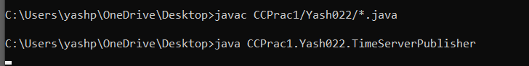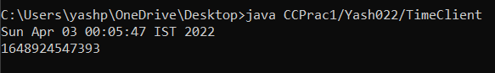

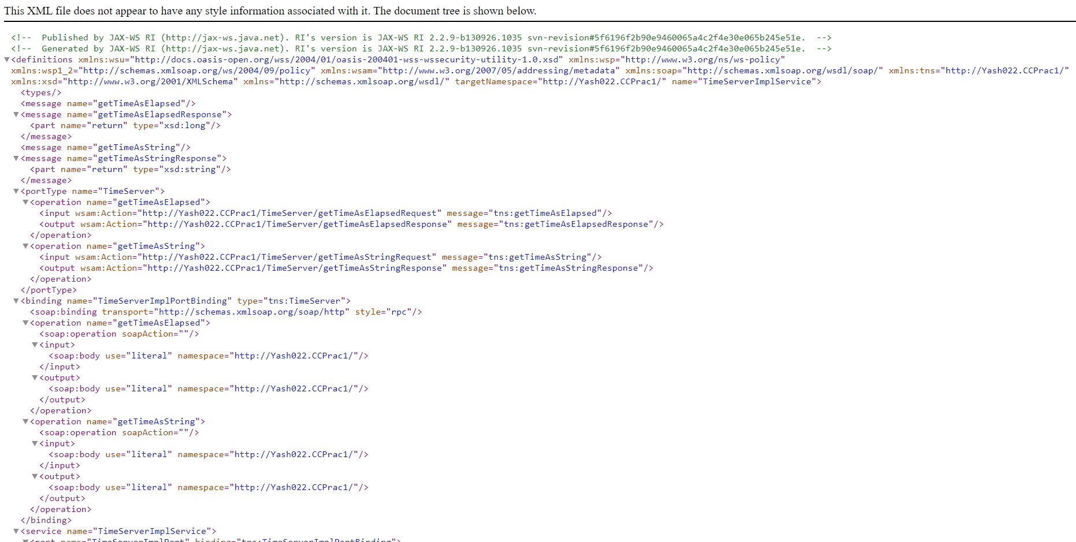

**Experiment no – 02**

**Aim: Develop web service in java that returns complex data types (e.g. as List of friends).**

**INPUT:**

**Player.java**

package team;

public class Player {

private String name;

private String nickname;

public Player() {

}

public Player(String name, String nickname) {

setName(name);

setNickname(nickname);

}

public void setName(String name) {

this.name = name;

}

public String getName() {

return name;

}

public void setNickname(String nickname) {

this.nickname = nickname;

}

public String getNickname() {

return nickname;

}

}

Team.java

package team;

import java.util.List;

public class Team {

private List<Player> players;

private String name;

public Team() {

}

public Team(String name, List<Player> players) {

setName(name);

setPlayers(players);

}

public void setName(String name) {

this.name = name;

}

public String getName() {

return name;

}

public void setPlayers(List<Player> players

) {

this.players = players;

}

public List<Player>getPlayers() {

return players;

}

public void setRosterCount(int n) {

}

public int getRosterCount() {

return (players == null) ? 0 : players.size();

}

}

TeamsPublisher.java

package team;

import java.util.List;

import javax.jws.WebService;

import javax.jws.WebMethod;

@WebService

public class Teams {

private TeamsUtility utils;

public Teams() {

utils = new TeamsUtility();

utils.make_test_teams();

}

@WebMethod

public Team getTeam(String name) {

return utils.getTeam(name);

}

@WebMethod

public List<Team> getTeams() {

return utils.getTeams();

}

}

TeamClient.java

package team;

import java.util.List;

class TeamClient {

public static void main(String[] args) {

TeamsService service = new TeamsService();

Teams port = service.getTeamsPort();

List<Team> teams = port.getTeams();

for (Team team : teams) {

System.out.println("Team name: " + team.getName()

+ " (roster count: " + team.getRosterCount() + ")");

for (Player player : team.getPlayers()) {

System.out.println(" Player: " + player.getNickname());

}

}

System.out.println(" Player: " + player.getNickname());

}

}

TeamPubliser.java

package team;

import javax.xml.ws.Endpoint;

class TeamsPublisher {

public static void main(String[] args) {

int port = 8888;

String url = "http://localhost:" + port + "/teams";

System.out.println("Publishing Teams on port " + port);

Endpoint.publish(url, new Teams());

}

}

TeamsUtility.java

package team;

import java.util.Set;

import java.util.List;

import java.util.ArrayList;

import java.util.Map;

import java.util.HashMap;

public class TeamsUtility {

private Map<String, Team> team_map;

public TeamsUtility() {

team_map = new HashMap<String, Team>();

}

public Team getTeam(String name) {

return team_map.get(name);

}

public List<Team> getTeams() {

List<Team> list = new ArrayList<Team>();

Set<String> keys = team_map.keySet();

for (String key : keys) {

list.add(team_map.get(key));

}

return list;

}

public void make_test_teams() {

List<Team> teams = new ArrayList<Team>();

Player chico = new Player("Leonard Marx", "Chico");

Player groucho = new Player("Julius Marx", "Groucho");

Player harpo = new Player("Adolph Marx", "Harpo");

List<Player> mb = new ArrayList<Player>();

mb.add(chico);

mb.add(groucho);

mb.add(harpo);

Team marx_brothers = new Team("Marx Brothers", mb);

teams.add(marx_brothers);

store_teams(teams);

}

private void store_teams(List<Team> teams) {

for (Team team : teams) {

team_map.put(team.getName(), team);

}

}

}

**OUTPUT**

**:**

**1**

**st**

**CMD:**

Compile all files except TeamClient

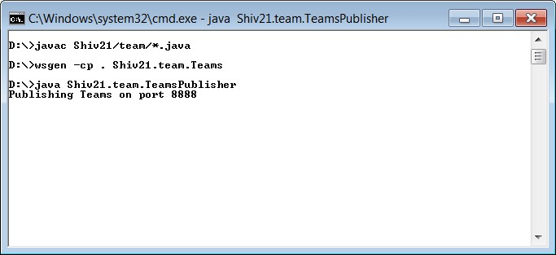

**Changes in the folder (added)**

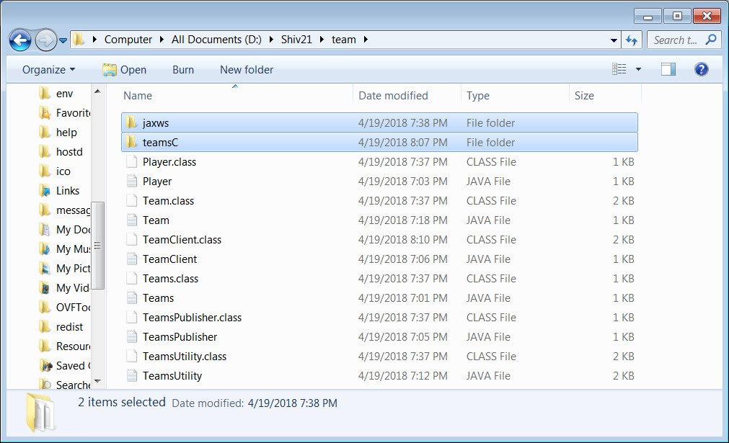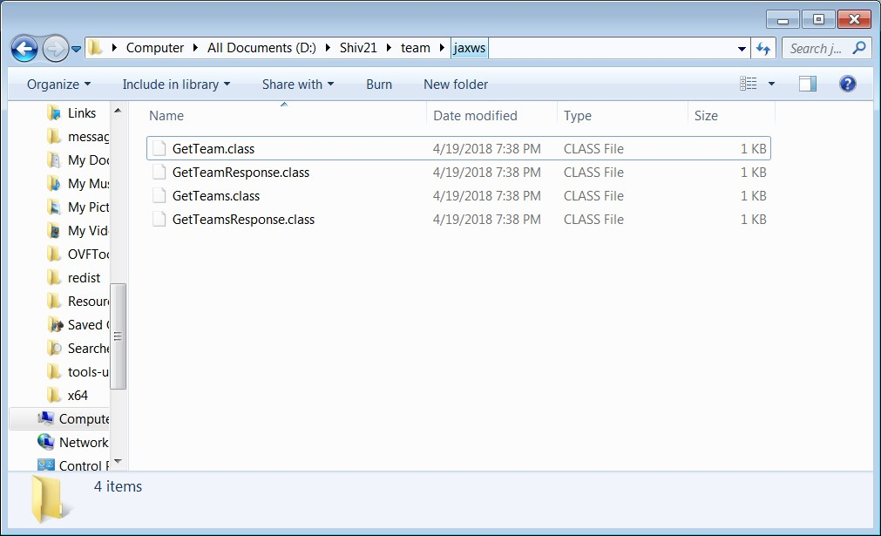

**2**

**nd**

**CMD:**

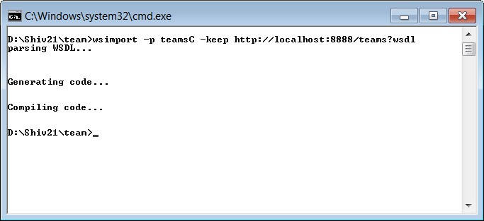

**Changes in the folder (added)**

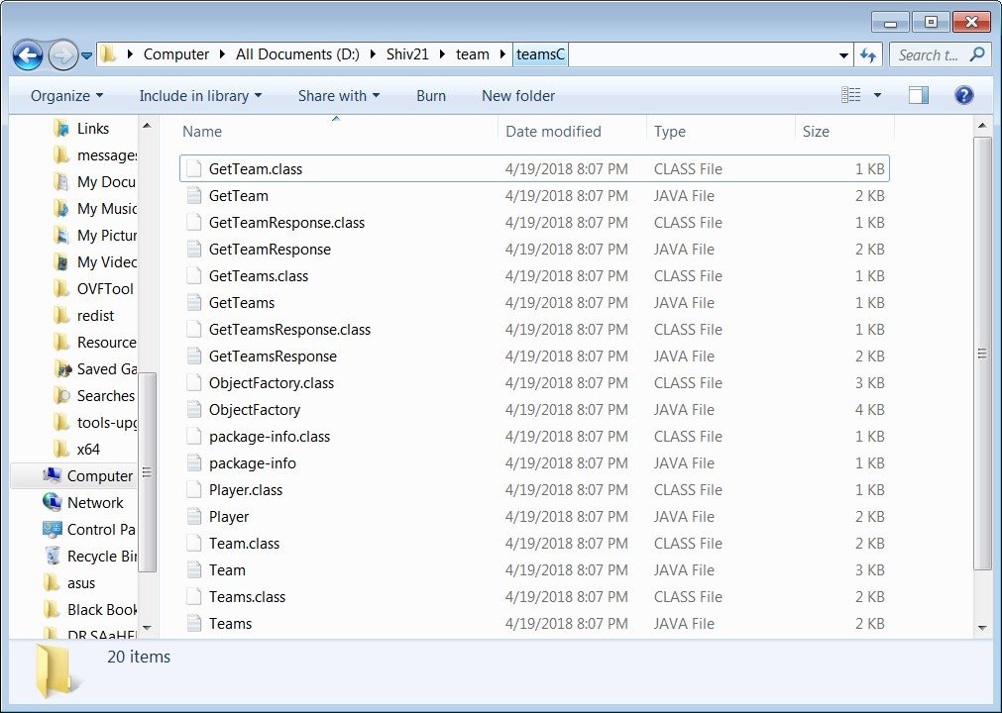

**3**

**rd**

**CMD:**

Now compile and run TeamClient.java

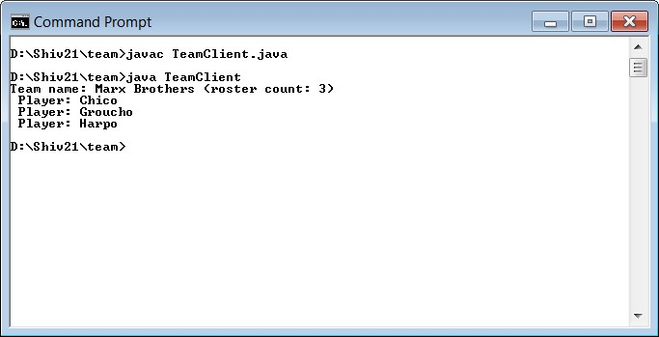

**WSDL:**

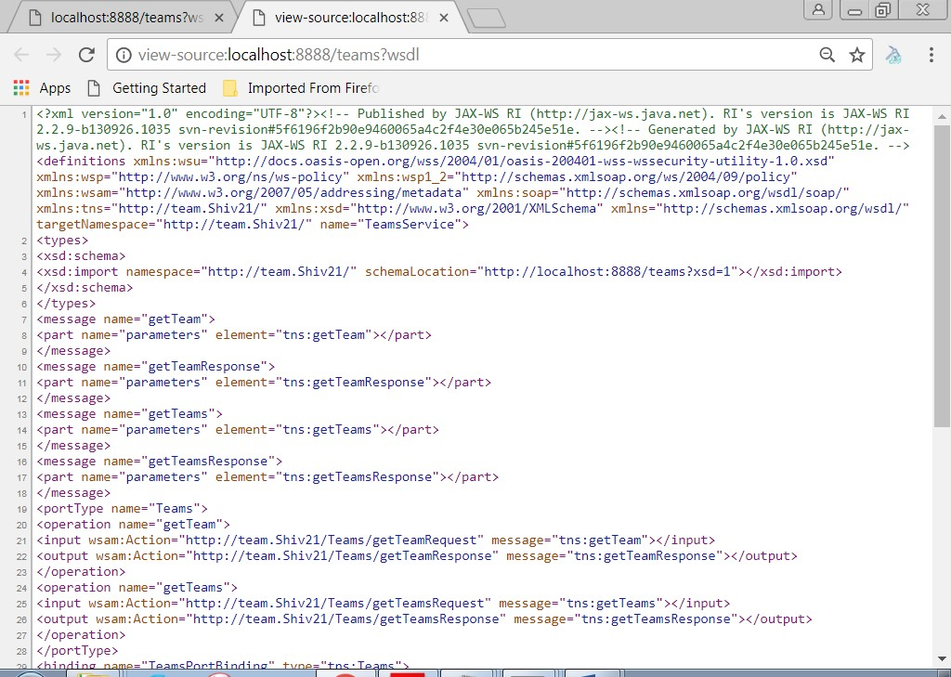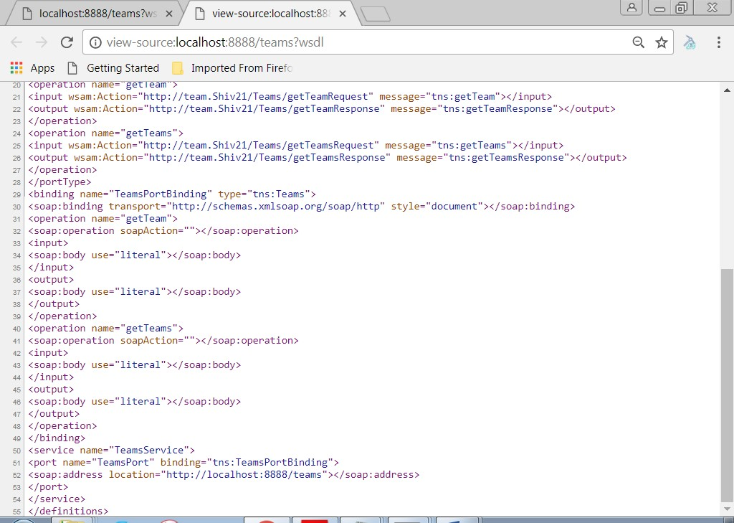

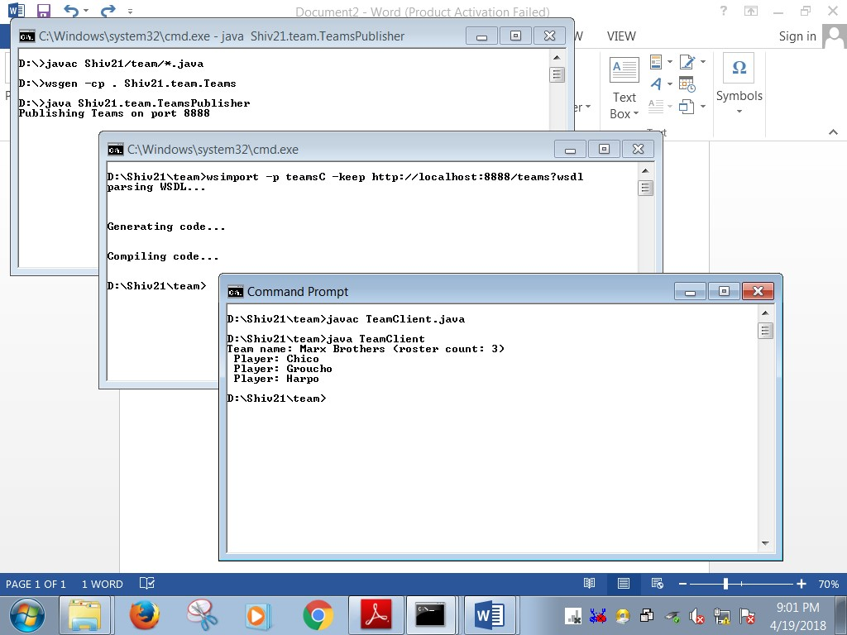

**Experiment no – 03**

**Aim:** **Develop Time Server service that returns current time in JAVA and call it from clients developed in JAVA, PHP, Android and .NET**

**INPUT:**

StrassenServerImpl.java

package CCPrac3;

import javax.jws.WebService;

@WebService(endpointInterface = "CCPrac3.StrassenServer")

public class StrassenServerImpl implements StrassenServer {

public int[][] multiply(int[][] A, int[][] B) {

int n = A.length;

int[][] R = new int[n][n];

if (n == 1) {

R[0][0] = A[0][0] * B[0][0];

} else {

int[][] A11 = new int[n / 2][n / 2];

int[][] A12 = new int[n / 2][n / 2];

int[][] A21 = new int[n / 2][n / 2];

int[][] A22 = new int[n / 2][n / 2];

int[][] B11 = new int[n / 2][n / 2];

int[][] B12 = new int[n / 2][n / 2];

int[][] B21 = new int[n / 2][n / 2];

int[][] B22 = new int[n / 2][n / 2];

split(A, A11, 0, 0);

split(A, A12, 0, n / 2);

split(A, A21, n / 2, 0);

split(A, A22, n / 2, n / 2);

split(B, B11, 0, 0);

split(B, B12, 0, n / 2);

split(B, B21, n / 2, 0);

split(B, B22, n / 2, n / 2);

int[][] M1 = multiply(add(A11, A22), add(B11, B22));

int[][] M2 = multiply(add(A21, A22), B11);

int[][] M3 = multiply(A11, sub(B12, B22));

int[][] M4 = multiply(A22, sub(B21, B11));

int[][] M5 = multiply(add(A11, A12), B22);

int[][] M6 = multiply(sub(A21, A11), add(B11, B12));

int[][] M7 = multiply(sub(A12, A22), add(B21, B22));

int[][] C11 = add(sub(add(M1, M4), M5), M7);

int[][] C12 = add(M3, M5);

int[][] C21 = add(M2, M4);

int[][] C22 = add(sub(add(M1, M3), M2), M6);

join(C11, R, 0, 0);

join(C12, R, 0, n / 2);

join(C21, R, n / 2, 0);

join(C22, R, n / 2, n / 2);

}

return R;

}

public int[][] sub(int[][] A, int[][] B) {

int n = A.length;

int[][] C = new int[n][n];

for (int i = 0; i < n; i++) {

for (int j = 0; j < n; j++) {

C[i][j] = A[i][j] - B[i][j];

}

}

return C;

}

public int[][] add(int[][] A, int[][] B) {

int n = A.length;

int[][] C = new int[n][n];

for (int i = 0; i < n; i++) {

for (int j = 0; j < n; j++) {

C[i][j] = A[i][j] + B[i][j];

}

}

return C;

}

public void split(int[][] P, int[][] C, int iB, int jB) {

for (int i1 = 0, i2 = iB; i1 < C.length; i1++, i2++) {

for (int j1 = 0, j2 = jB; j1 < C.length; j1++, j2++) {

C[i1][j1] = P[i2][j2];

}

}

}

public void join(int[][] C, int[][] P, int iB, int jB) {

for (int i1 = 0, i2 = iB; i1 < C.length; i1++, i2++) {

for (int j1 = 0, j2 = jB; j1 < C.length; j1++, j2++) {

P[i2][j2] = C[i1][j1];

}

}

}

public String StrassenMessage(String sreq) {

String MatrixC = "";

System.out.println("Server: StrassenMessage() invoked...");

System.out.println("Server: Message > " + sreq);

int idx = sreq.indexOf(",");

int N = Integer.parseInt(sreq.substring(0, idx));

System.out.println("N=" + N);

int t = 0;

int[][] A = new int[N][N];

int[][] B = new int[N][N];

int[][] C = new int[N][N];

for (int i = 0; i < N; i++) {

for (int j = 0; j < N; j++) {

int from = sreq.indexOf(',', t

);

int to = sreq.indexOf(',', from

+ 1

);

A[i][j] = Integer.parseInt(sreq.substring(from + 1, to));

t = to;

}

}

for (int i = 0; i < N; i++) {

for (int j = 0; j < N; j++) {

int from = sreq.indexOf(',', t);

int to = sreq.indexOf(',', from + 1);

B[i][j] = Integer.parseInt(sreq.substring(from + 1, to));

t = to;

}

}

int[][] MAT = multiply(A, B);

StringBuilder MatC = new StringBuilder();

MatC.append(N + ",");

for (int i = 0; i < N; i++) {

for (int j = 0; j < N; j++) {

MatC.append(MAT[i][j]);

if (i == N - 1 && j == N - 1) {

MatC.append("");

} else {

MatC.append(",");

}

}

System.out.println();

}

MatrixC = MatC.toString();

return (MatrixC);

}

}

StrassenServer.java

package CCPrac3;

import javax.jws.WebService;

import javax.jws.WebMethod;

import javax.jws.soap.SOAPBinding;

import javax.jws.soap.SOAPBinding.Style;

@WebService // This signals that this is a Service Endpoint Interface (SEI)

@SOAPBinding(style = Style.RPC)

public interface StrassenServer {

@WebMethod // This signals that this method is a service operation

String StrassenMessage(String strMsg);

}

StrassenPublisher.java

package CCPrac3;

import javax.xml.ws.Endpoint;

public class StrassenServerPublisher {

public static void main(String[] args) {

Endpoint.publish("http://localhost:9876/strassen", new StrassenServerImpl());

}

}

StrassenClient.java

package CCPrac3;

import javax.xml.namespace.QName;

import javax.xml.ws.Service;

import java.net.URL;

class StrassenClient {

public static void main(String argv[]) throws Exception {

long start, finish, difference;

if (argv.length < 1) {

System.out.println("Usage: java StrassenClient \"N,matrix elements separated by ,\"");

System.exit(1);

}

String strMsg = argv[0];

URL url = new URL("http://localhost:9876/strassen?wsdl");

QName qname = new QName("http://CCPrac3/", "StrassenServerImplService");

Service service = Service.create(url, qname);

StrassenServer eif = service.getPort(StrassenServer.class);

start = System.currentTimeMillis();

String sreq = eif.StrassenMessage(strMsg);

finish = System.currentTimeMillis();

sreq = sreq + ",";

int idx = sreq.indexOf(",");

int N = Integer.parseInt(sreq.substring(0, idx));

int t = 0;

int[][] C = new int[N][N];

for (int i = 0; i < N; i++) {

for (int j = 0; j < N; j++) {

int from = sreq.indexOf(',', t);

int to = sreq.indexOf(',', from + 1);

C[i][j] = Integer.parseInt(sreq.substring(from + 1, to));

t = to;

}

}

System.out.println("\nMatrix Multiplication is ...\n");

for (int i = 0; i < N; i++) {

for (int j = 0; j < N; j++) {

System.out.print(C[i][j] + " ");

}

System.out.println();

}

difference = finish - start;

System.out.println("Time required for matrix multiplication (Using Strassen algorithm) :");

System.out.println(difference + " milli seconds");

}

}

Output:

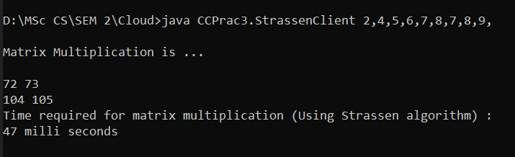

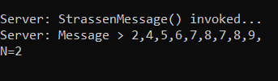

**Conclusion:** Successfully Develop and Implemented Time Server service that returns current time in JAVA and call it from clients developed in JAVA**.**

**Experiment no – 04**

**AIM:** Demonstrate CRUD operations with suitable database using SOAP or RESTful Web service.

**INPUT:**

Server.java

package webservice.prac4;

import javax.jws.WebService; import javax.jws.WebMethod; import javax.jws.soap.SOAPBinding; import javax.jws.soap.SOAPBinding.Style; import java.util.*;

@WebService

@SOAPBinding(style = Style.RPC)

public interface Server {

@WebMethod int insertFriend(String name,String addr);

@WebMethod String[] getFriend(int id);

@WebMethod boolean deleteFriend(int id); }

ServerImplement.java

package CCPrac4;

import java.sql.*;

import java.util.*;

import javax.jws.WebService;

@WebService(endpointInterface = "CCPrac4.Server")

public class ServerImplement implements Server {

private static final String url = "jdbc:mysql://localhost:3306/library";

private static final String user = "root";

private static final String password = "";

public String[] getFriend(int id){

String[] data = new String[2];

try {

Connection con = DriverManager.getConnection(url, user, password);

Statement stmt = null;

stmt = con.createStatement();

String sql = "SELECT * FROM `friends` Where `id`="+id;

ResultSet rs = stmt.executeQuery(sql);

while(rs.next()) {

data[0] = rs.getString("name");

data[1] = rs.getString("addr");

}

rs.close();

} catch (Exception e) {

e.printStackTrace();

}

return data;

}

public int insertFriend(String name,String addr){

int id = 0;

try {

Connection con = DriverManager.getConnection(url, user, password);

String query = "Insert into friends (name,addr)" + " values (?, ?)";

PreparedStatement preparedStmt =

con.prepareStatement(query,Statement.RETURN_GENERATED_KEYS);

preparedStmt.setString (1, name);

preparedStmt.setString (2, addr);

preparedStmt.executeUpdate();

ResultSet rs=preparedStmt.getGeneratedKeys();

if(rs.next()) {

id=rs.getInt(1);

}

} catch (Exception e) {

e.printStackTrace();

}

return id;

}

public boolean deleteFriend(int id){

boolean stat = false;

try {

Connection con = DriverManager.getConnection(url, user, password);

String query = "Delete from friends where id = ?";

PreparedStatement preparedStmt = con.prepareStatement(query);

preparedStmt.setInt (1, id);

preparedStmt.execute();

stat = true;

} catch (Exception e) {

e.printStackTrace();

}

return stat;

}

}

ServerPubliser.java

package CCPrac4;

import javax.xml.ws.Endpoint;

public class ServerPublisher {

public static void main(String[] args) {

Endpoint.publish("http://127.0.0.1:9876/ccprac4",new ServerImplement());

}

}

Client.java

package CCPrac4;

import javax.xml.namespace.QName;

import javax.xml.ws.Service;

import java.net.URL;

import java.util.*;

class Client {

public static void main(String args[]) throws Exception {

URL url = new URL("http://127.0.0.1:9876/ccprac4?wsdl");

QName qname = new QName("http://CCPrac4/", "ServerImplement");

Service service = Service.create(url, qname);

Server eif = service.getPort(Server.class);

Scanner s = new Scanner(System.in);

System.out.println("1 > Add Friend");

System.out.println("2 > Get Friend By Id");

System.out.println("3 > Delete Friend");

System.out.print("Enter Your Option:");

int op = s.nextInt();

int id = 0;

String name="",addr="";

switch(op) {

case 1:

System.out.print("Enter Friends Name:");

name=s.next();

System.out.print("\nEnter Friends Address:");

addr=s.next();

int a = eif.insertFriend(name,addr);

if(a>0) {

System.out.println("Your Friend has been Added with Id:"+a);

}

break;

case 2:

System.out.print("Enter Friends ID:");

id=s.nextInt();

String[] data = eif.getFriend(id);

System.out.println("Name:"+data[0]+"\nAddress:"+data[1]);

break;

case 3:

System.out.print("Enter Friends ID To Delete:");

id=s.nextInt();

if(eif.deleteFriend(id)) {

System.out.println("Friend has been Deleted");

}

break;

default:

System.out.print("No Such Options!!!!\n Try pressing Another Key:");

break;

}

}

}

**OUTPUT:**

**Server Side:**

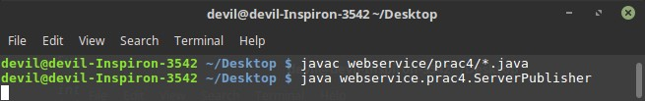

**Client Side:**

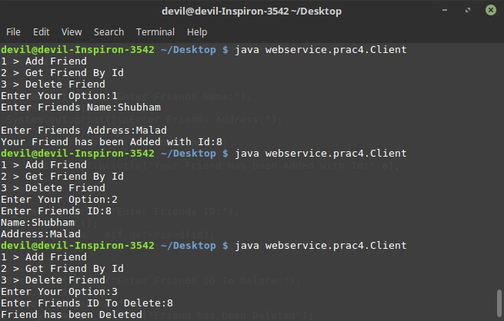

**Experiment no – 05**

**Aim: Create a Virtual Private Cloud in AWS.**

**Steps:**

1. **Create VPC**

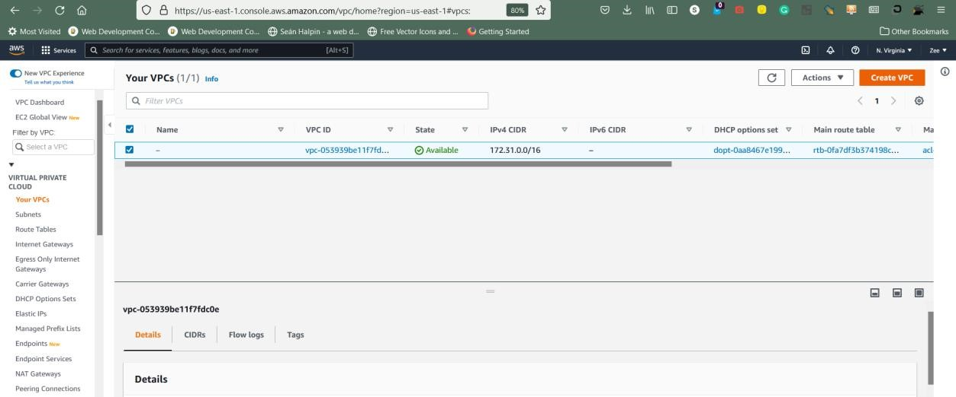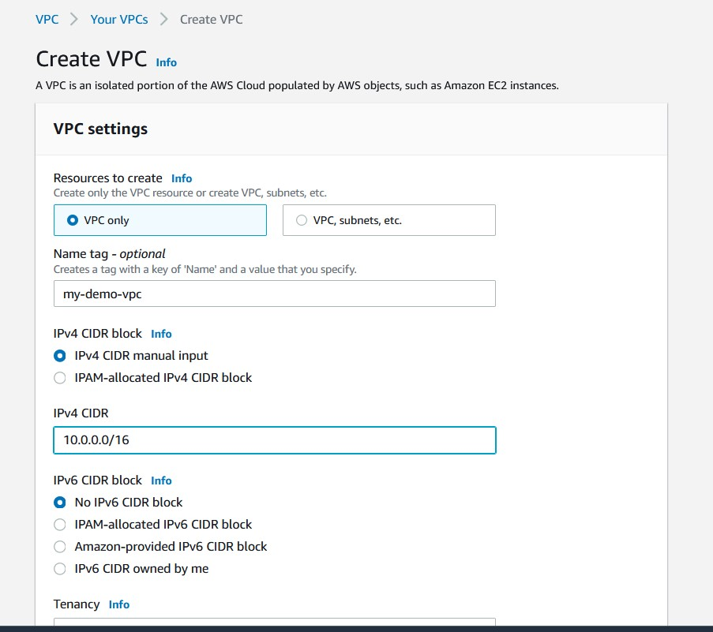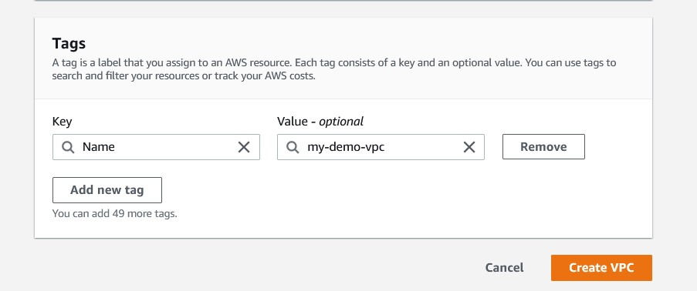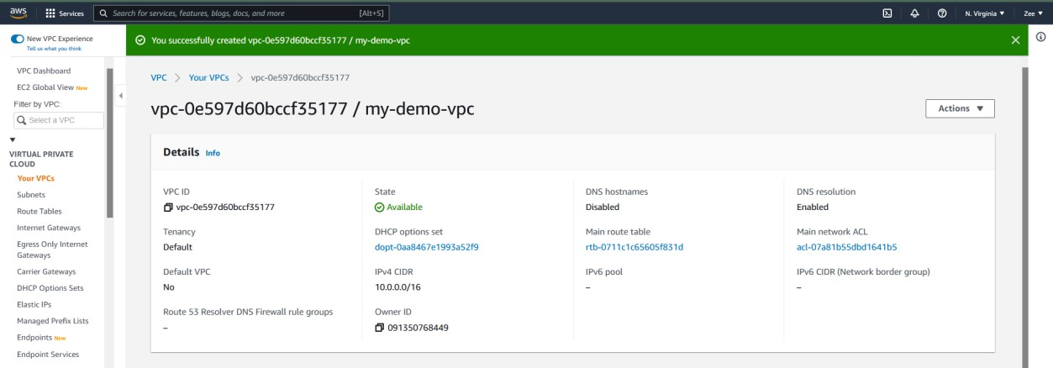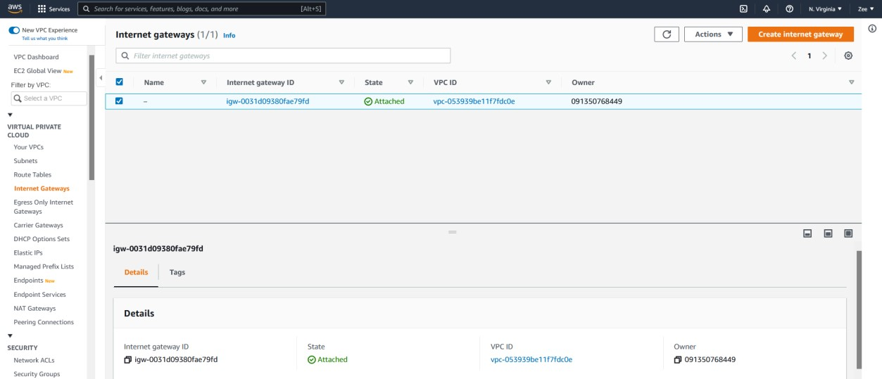

1. **Create Internet Gateway**

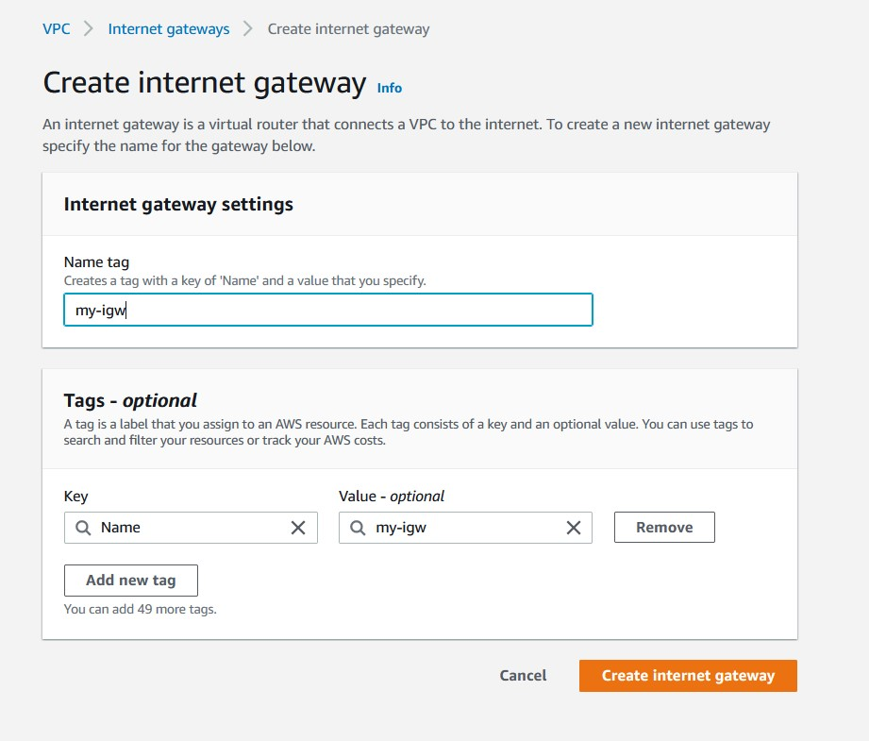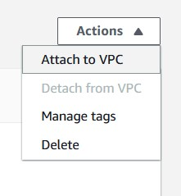

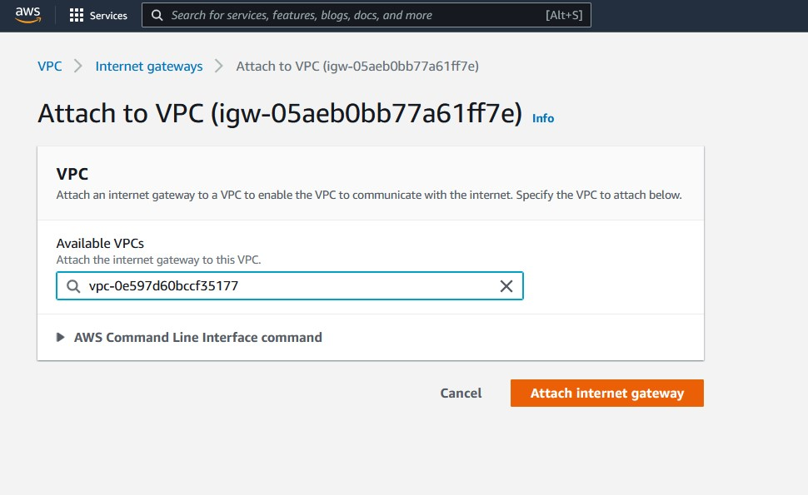

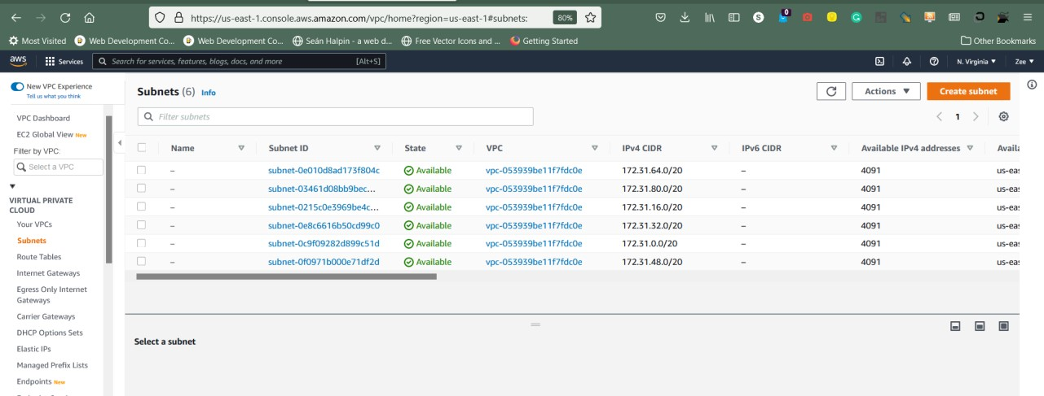

1. **Create Subnet.**
2. **Configure Subnet for public and private instance.**

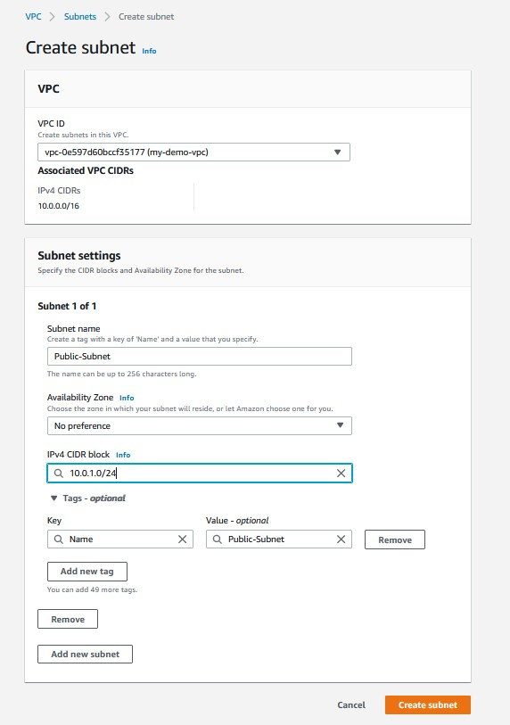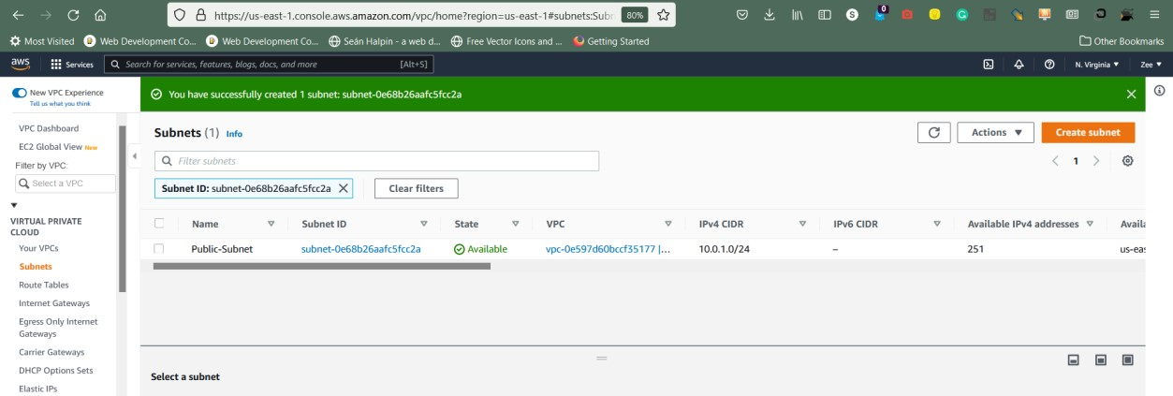

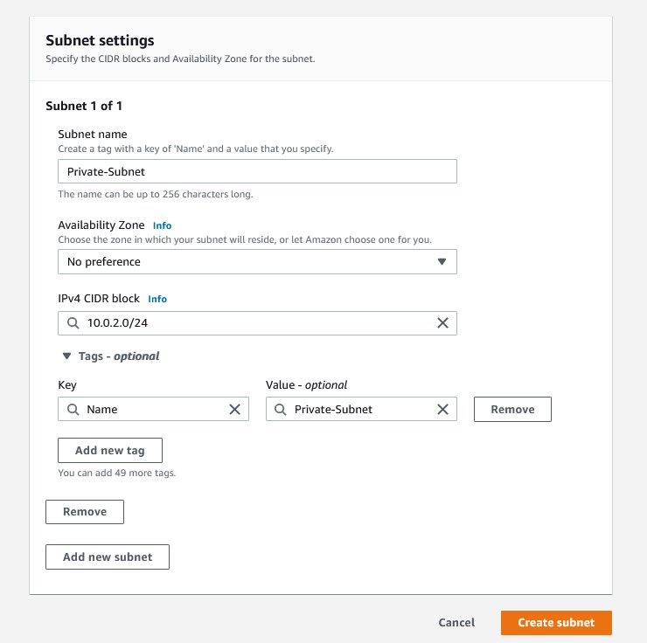

1. **Create Routes in routing Table.**

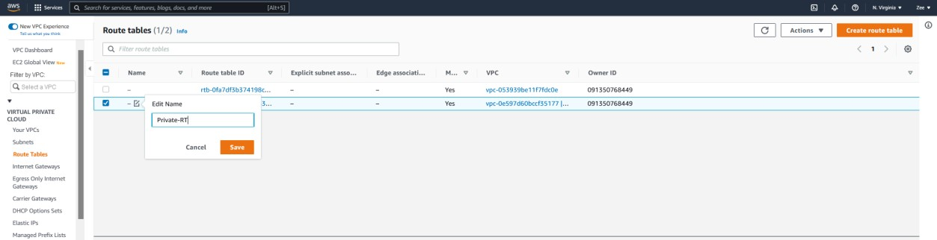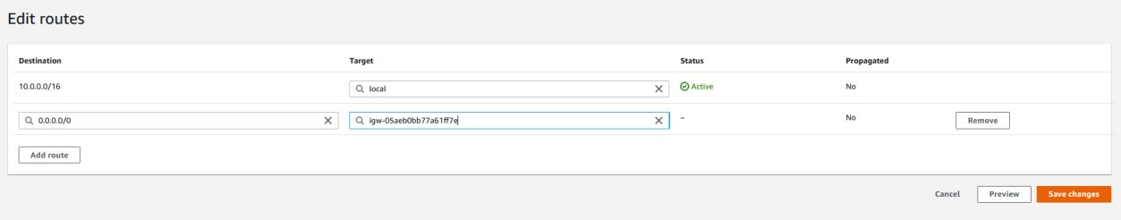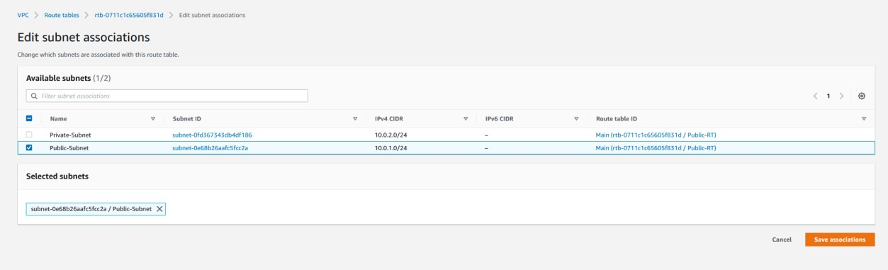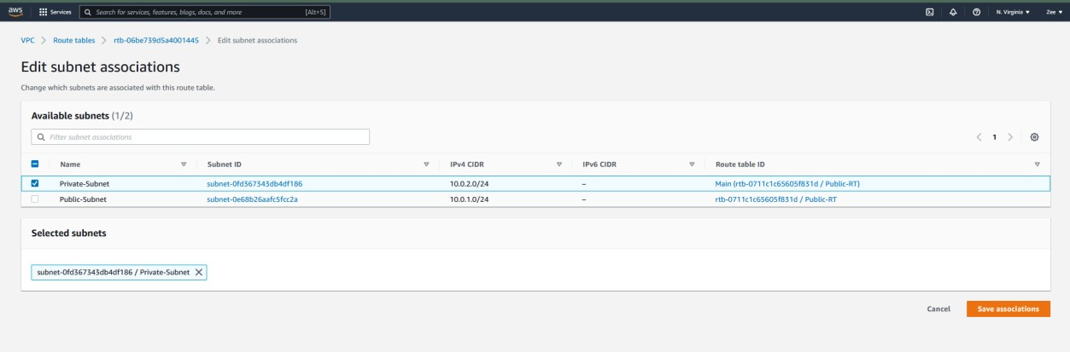

1. **Create Security groups.**

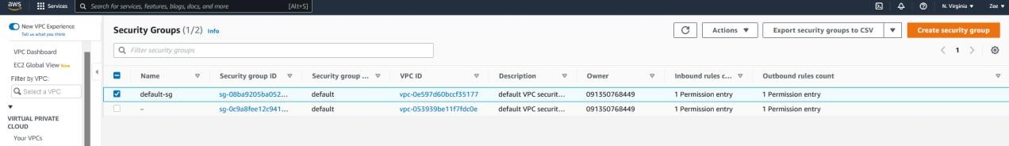

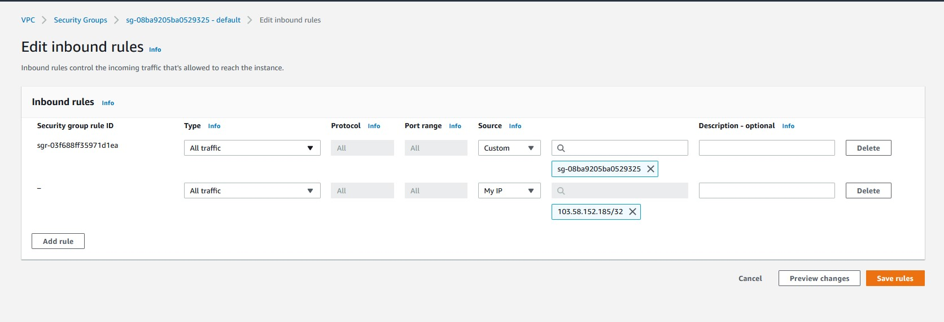

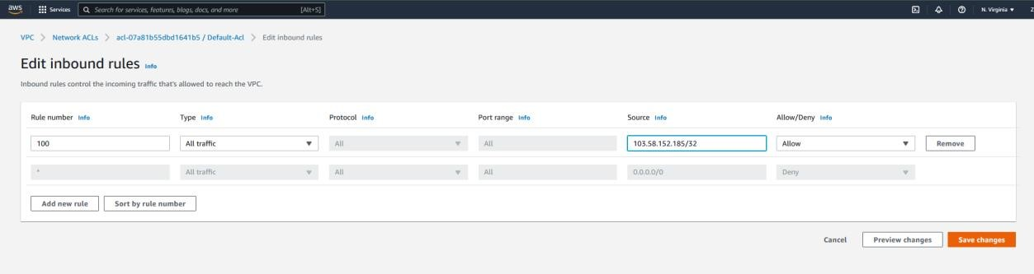

1. **Create a public instance.**

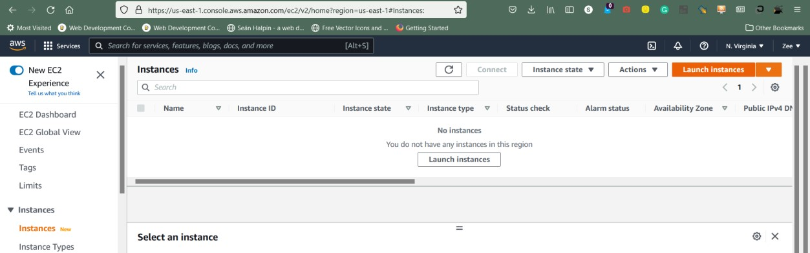

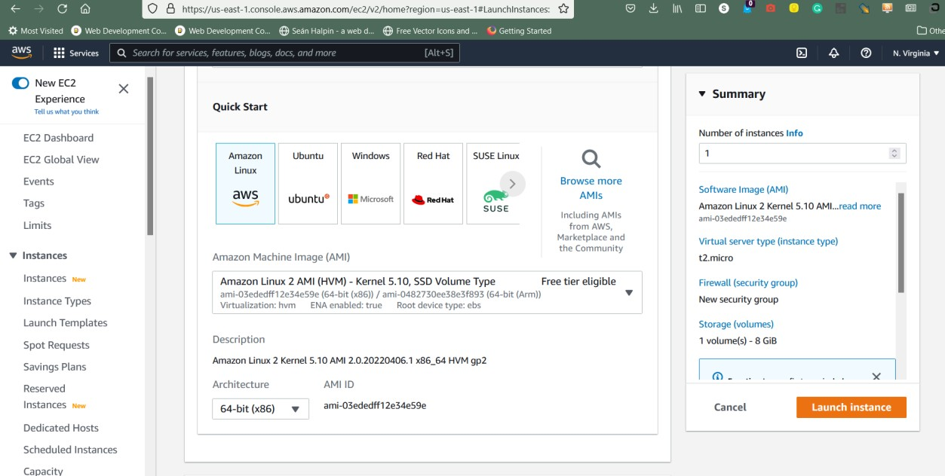

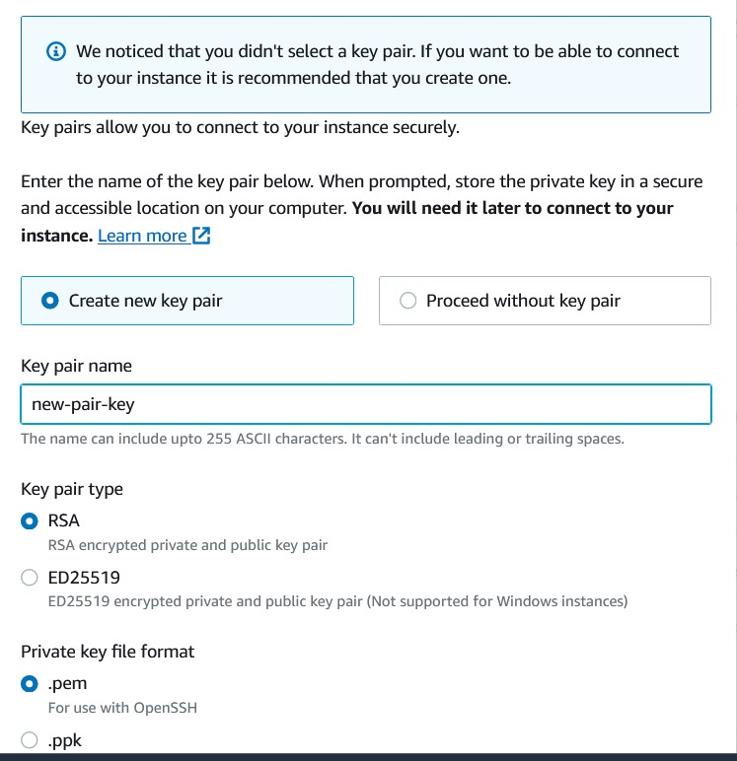

1. **Create a private instance.**

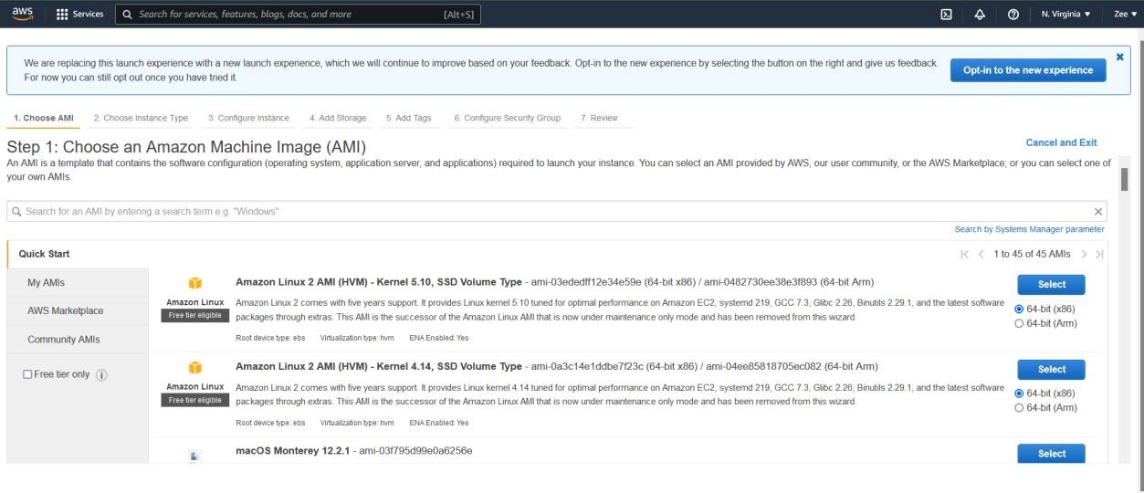

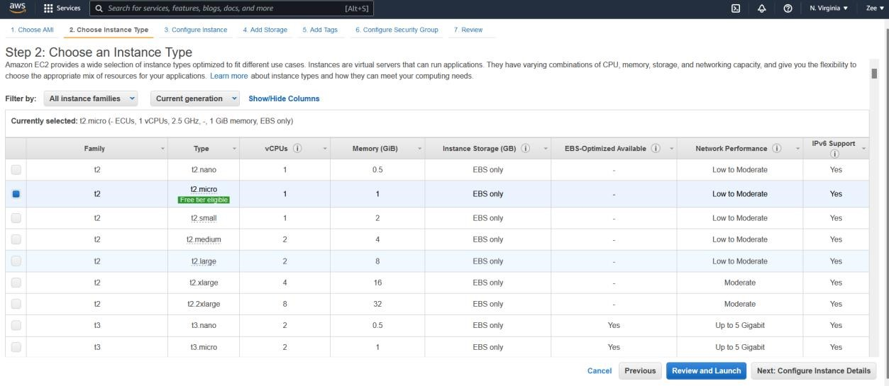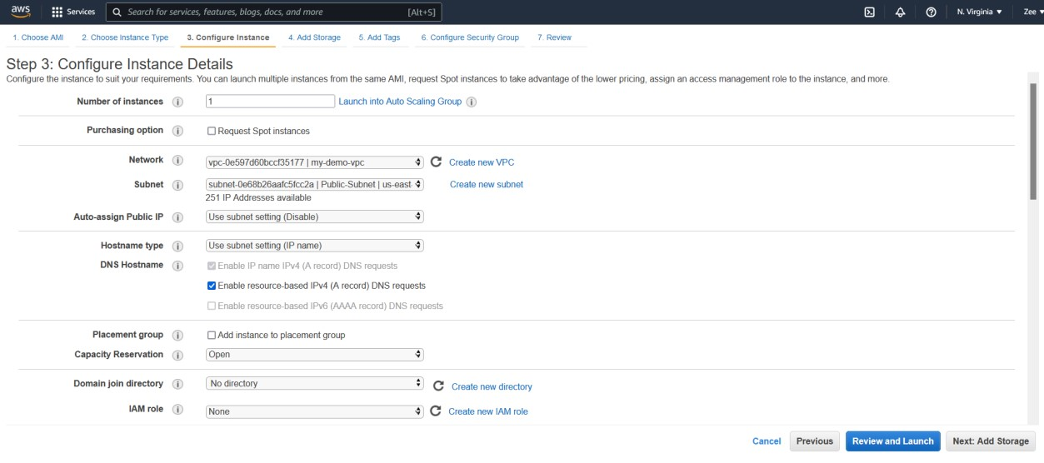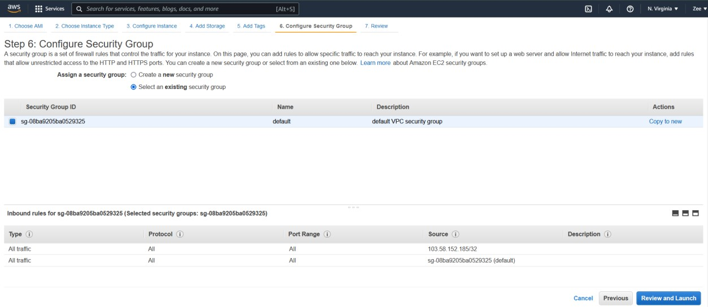

1. **Ping public-ec2 instance.**

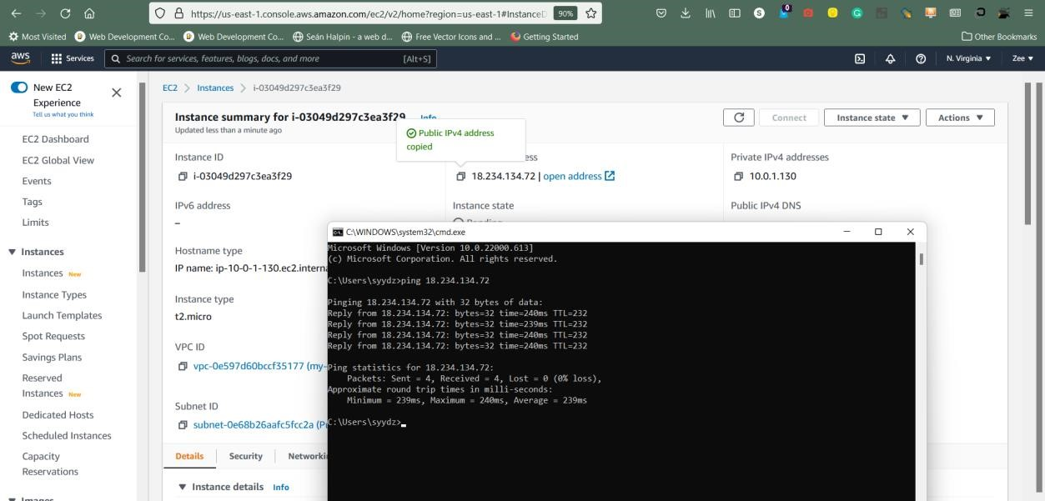

1. **Ping private-ec2 instance.**

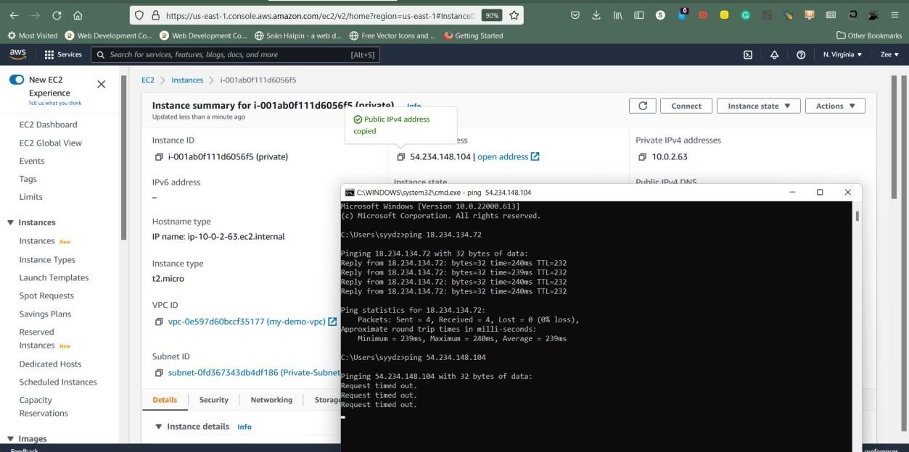

**Conclusion:** Virtual private cloud implemented successfully.

**Experiment no – 06**

**Aim: Develop WCF service returning response in JSON type.**

**INPUT:**

//MyService.svc.cs

using System;

using System.Collections.Generic;

using System.Linq;

using System.Runtime.Serialization;

using System.ServiceModel;

using System.Text;

namespace MyWCFService1

{

// NOTE: You can use the "Rename" command on the "Refactor" menu to change the class name "MyService1" in code, svc and config file together.

// NOTE: In order to launch WCF Test Client for testing this service, please select MyService1.svc or MyService1.svc.cs at the Solution Explorer and start debugging.

public class MyService1 : IMyService1

{

public string Message(string name)

{

return "Hello" + " " + name;

}

public string Prod_id(string id)

{

return "Your product id is" + " " + id;

}

}

}

//IMyService1.cs

using System;

using System.Collections.Generic;

using System.Linq;

using System.Runtime.Serialization;

using System.ServiceModel;

using System.Text;

namespace MyWCFService1

{

// NOTE: You can use the "Rename" command on the "Refactor" menu to change the class name "MyService1" in code, svc and config file together.

// NOTE: In order to launch WCF Test Client for testing this service, please select MyService1.svc or MyService1.svc.cs at the Solution Explorer and start debugging.

public class MyService1 : IMyService1

{

public string Message(string name)

{

return "Hello" + " " + name;

}

public string Prod_id(string id)

{

return "Your product id is" + " " + id;

}

}}

//Web.config

<?xml version="1.0"?>

<configuration>

<appSettings>

<add key="aspnet:UseTaskFriendlySynchronizationContext" value="true" />

</appSettings>

<system.web>

<compilation debug="true" targetFramework="4.5" />

<httpRuntime targetFramework="4.5"/>

</system.web>

<system.serviceModel>

<behaviors>

<serviceBehaviors>

<behavior name ="ServiceBehavior">

<!-- To avoid disclosing metadata information, set the values below to false before deployment -->

<serviceMetadata httpGetEnabled="true" httpsGetEnabled="true"/>

<!-- To receive exception details in faults for debugging purposes, set the value below to true. Set to false before deployment to avoid disclosing exception information -->

<serviceDebug includeExceptionDetailInFaults="false"/>

</behavior>

</serviceBehaviors>

<endpointBehaviors >

<behavior name="web">

<webHttp />

</behavior>

</endpointBehaviors>

</behaviors>

<services>

<service name="MyWCFService1.MyService1" behaviorConfiguration ="ServiceBehavior">

<endpoint binding ="webHttpBinding" contract ="MyWCFService1.IMyService1" behaviorConfiguration ="web">

</endpoint>

</service>

</services>

<protocolMapping>

<add binding="basicHttpsBinding" scheme="https" />

</protocolMapping>

<serviceHostingEnvironment aspNetCompatibilityEnabled="true" multipleSiteBindingsEnabled="true" />

</system.serviceModel>

<system.webServer>

<modules runAllManagedModulesForAllRequests="true"/>

<!--

To browse web app root directory during debugging, set the value below to true.

Set to false before deployment to avoid disclosing web app folder information.

-->

<directoryBrowse enabled="true"/>

</system.webServer>

</configuration>

**OUTPUT:**

**Debugging the Project:**

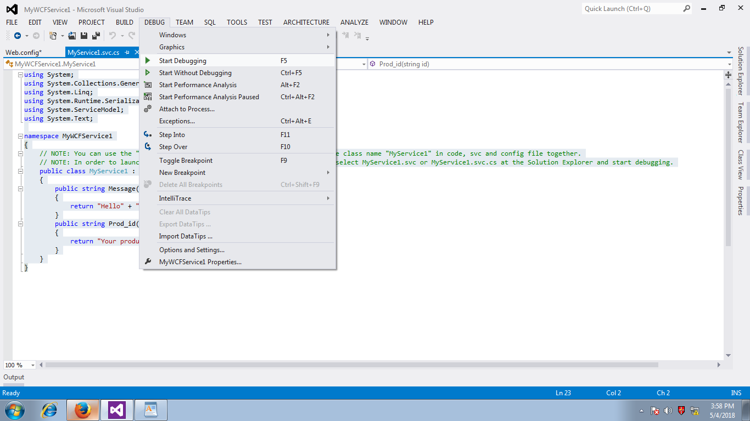

Adding The Service:

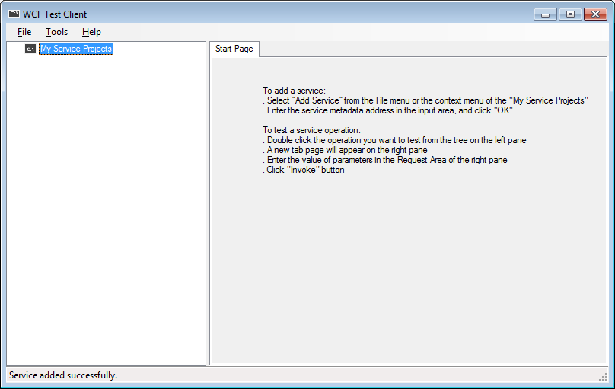

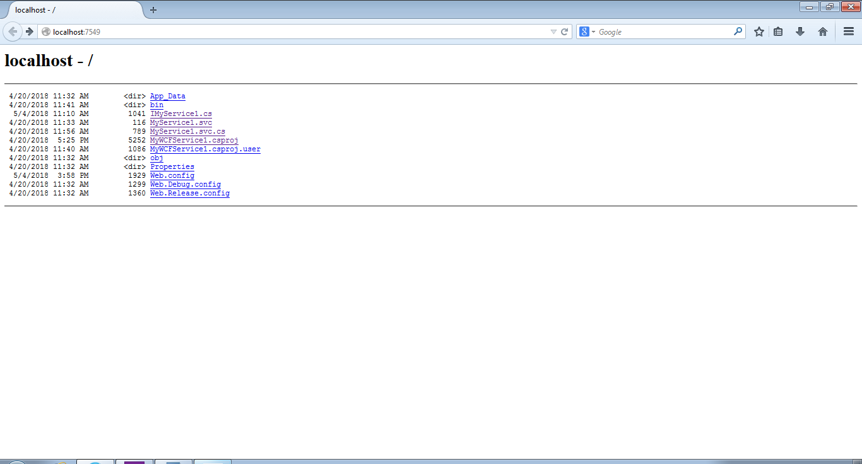

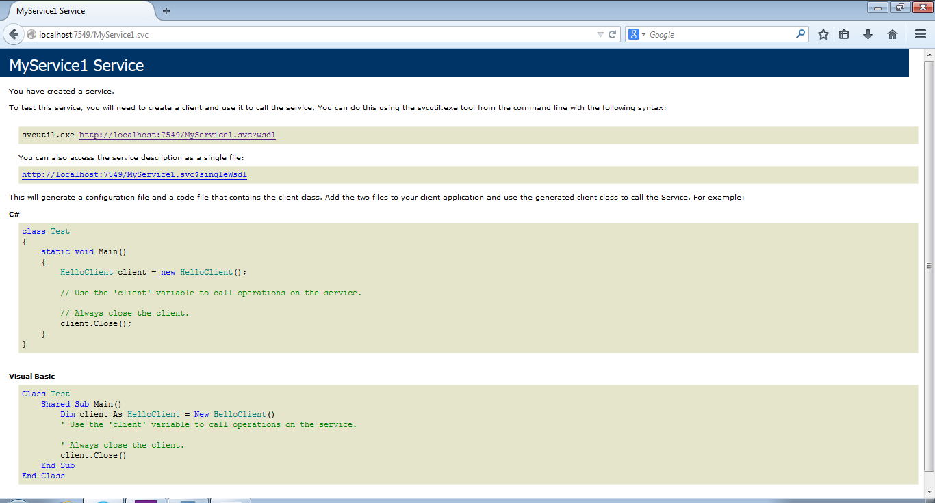

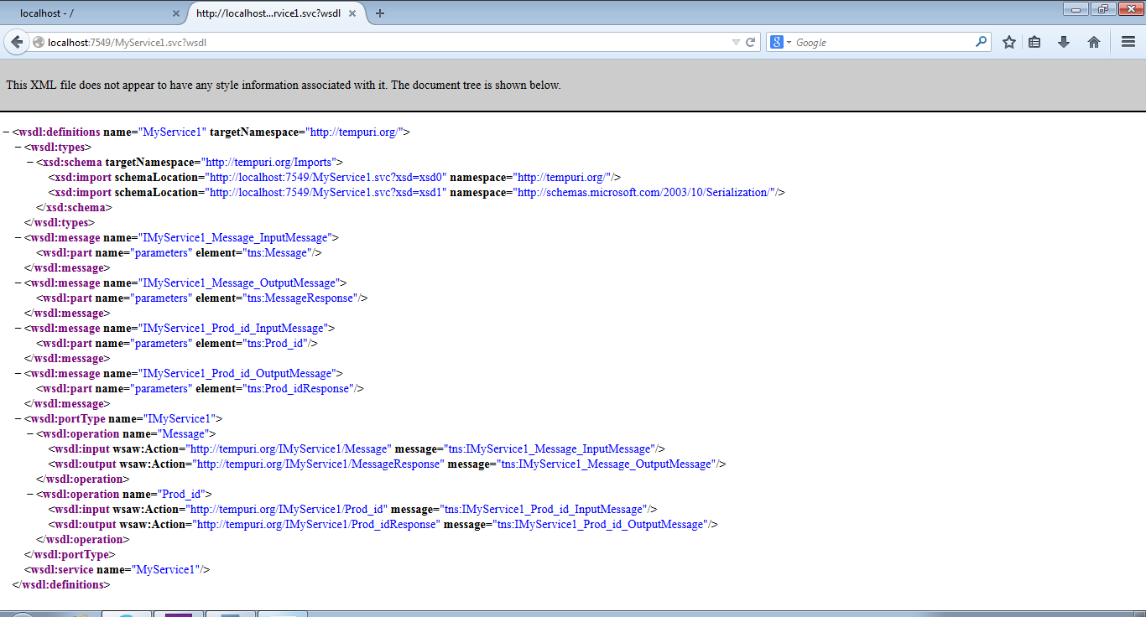

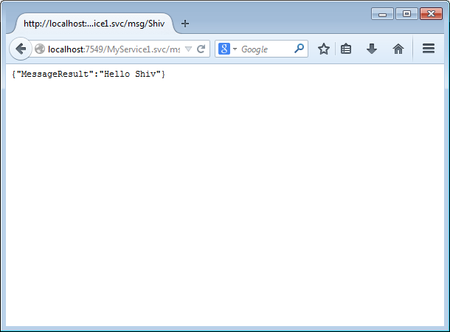

**Experiment no – 07**

**Aim: Perform IAM (Identity and Access Management) Operations in AWS.**

**A) MFA**

**Steps:**

1. **Log in to your Aws Console.**
2. **Search AWS inside search bar.**

3)

On IAM Dashbo

ard Click

-

On Add MFA

4)

Cli

ck on Acti

vate MFA

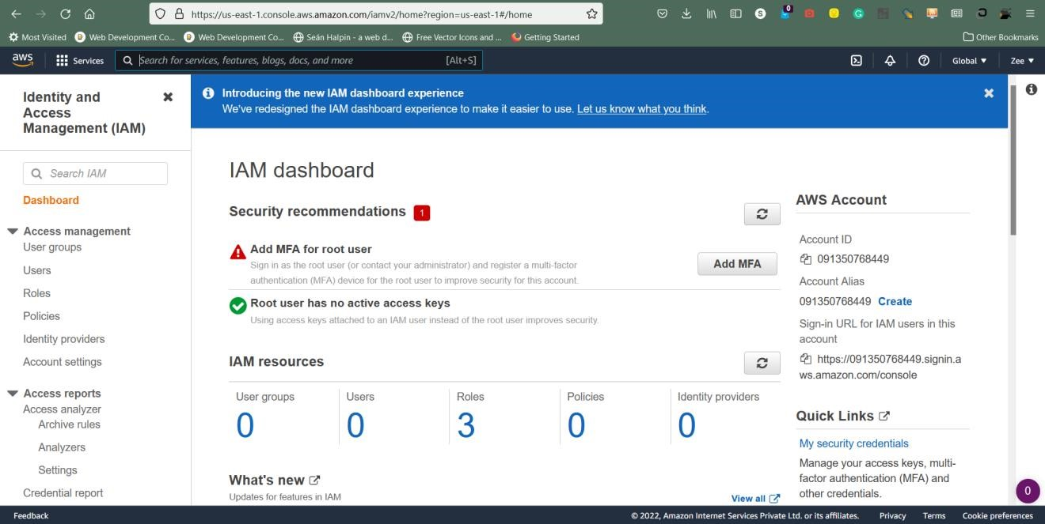

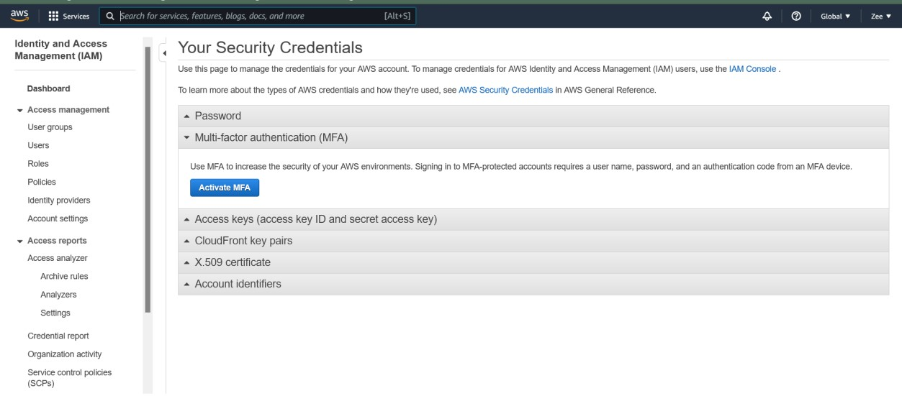

1. **Install Authy From Android Play Store**

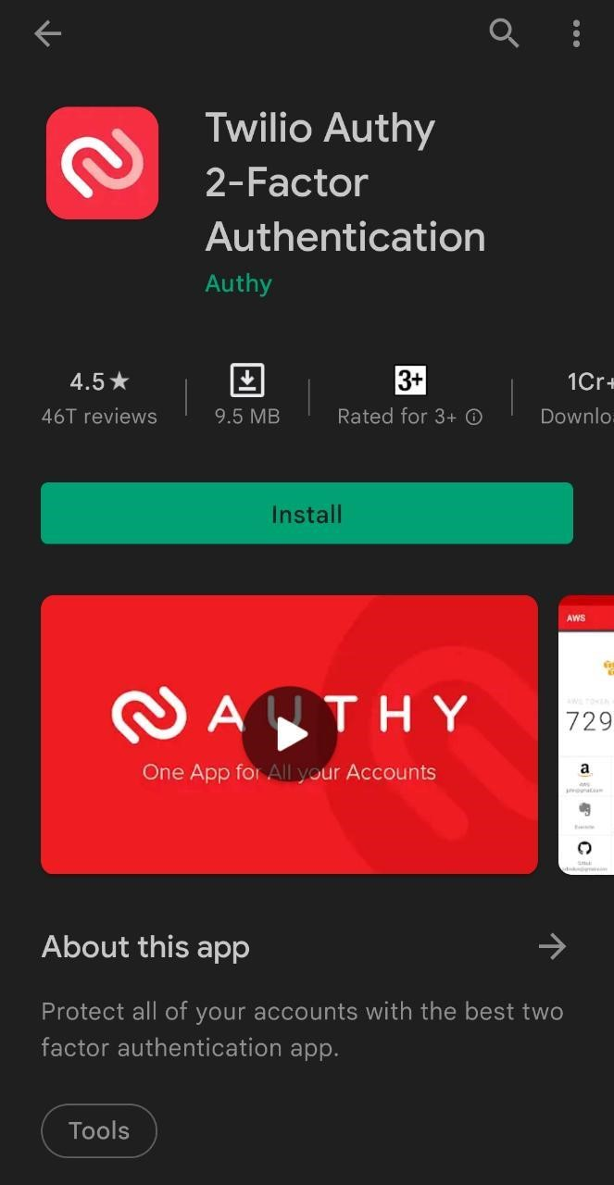

1. **Scan QR Code from Authy.**
2. **Enter 2 consecutive MFA codes.**

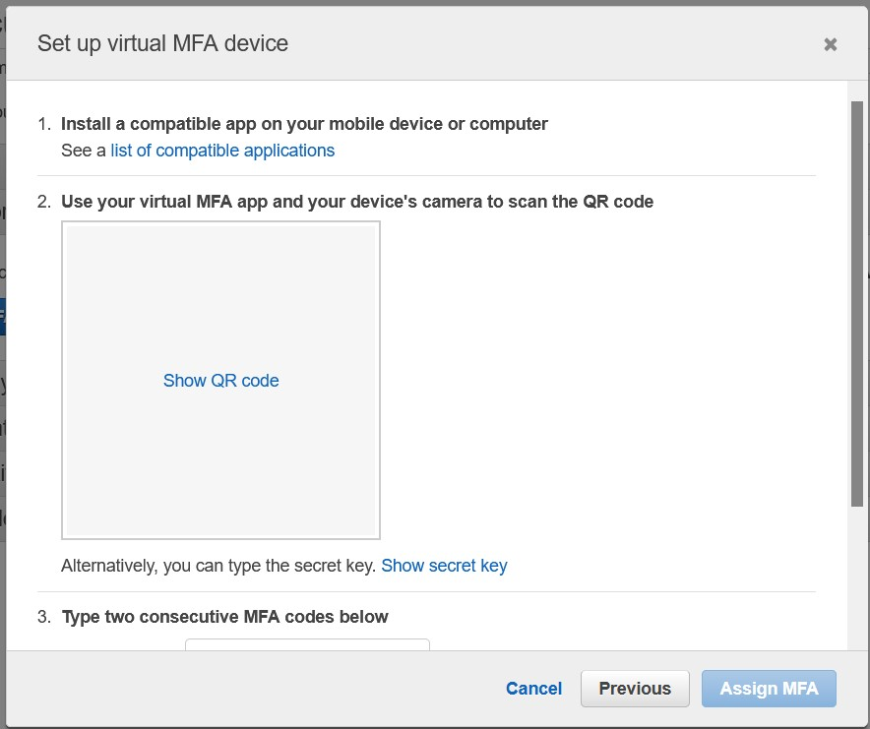

1. **Click on Assign MFA**

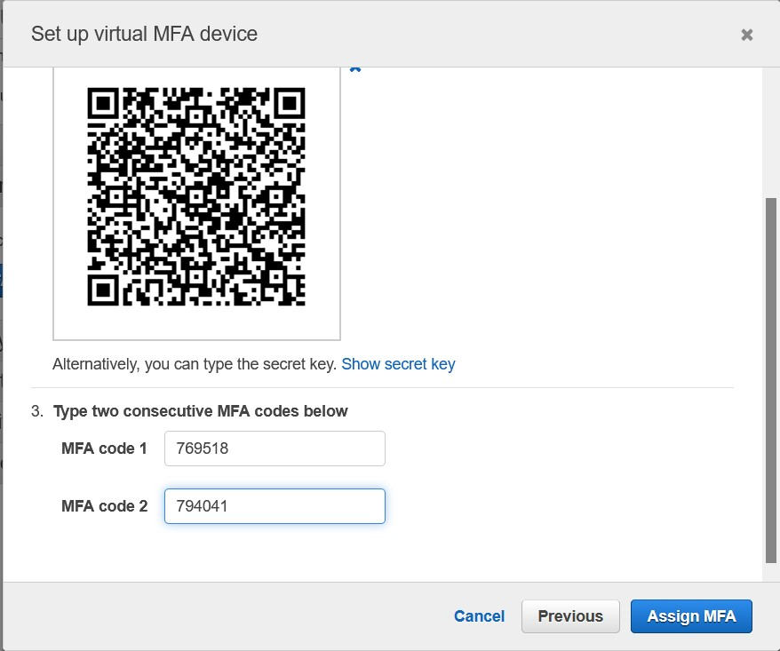

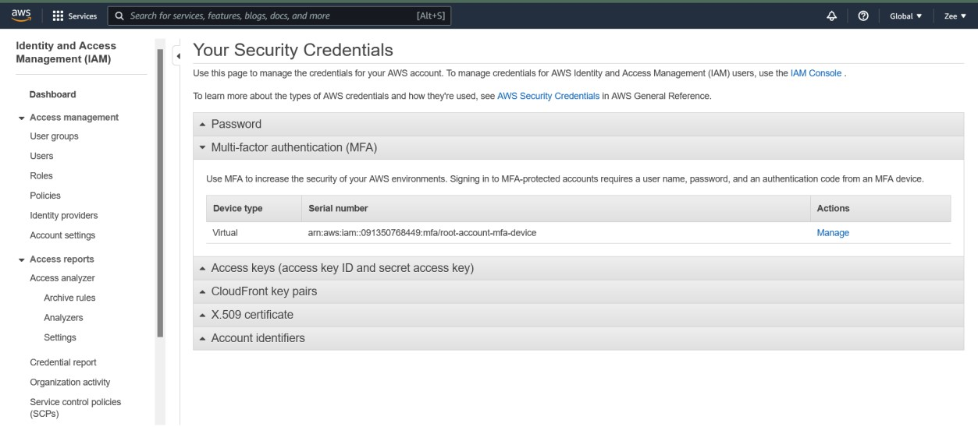

1. **Multifactor Authentication has been successfully implemented.**

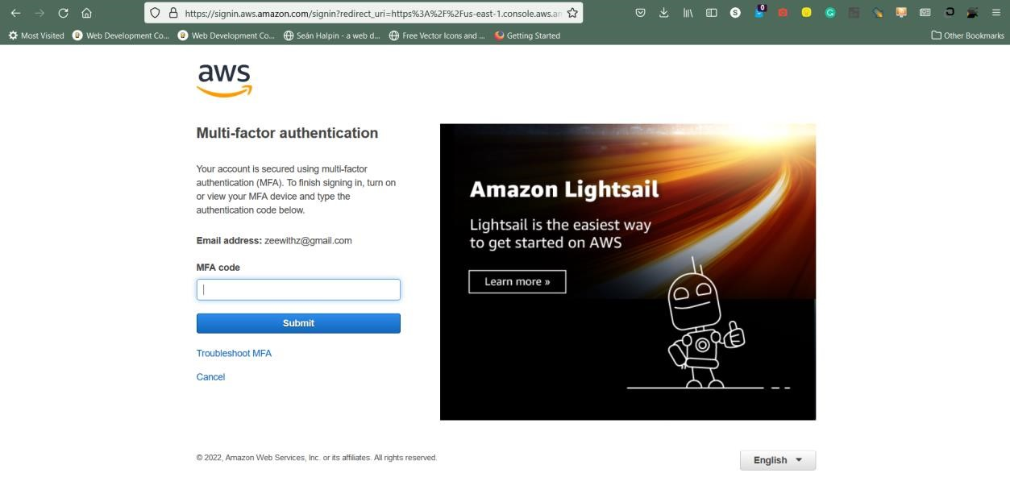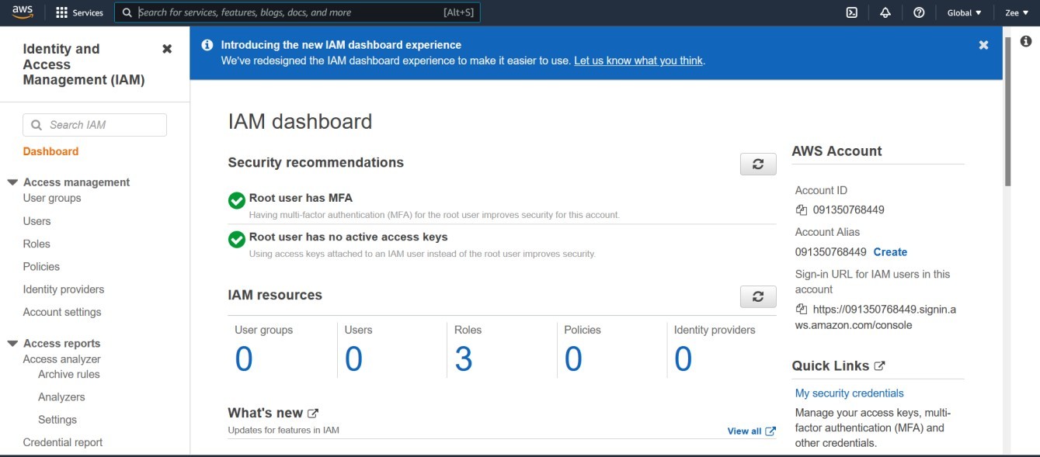

**B) Create users**

**Steps:**

1. **Click-On Add Users**

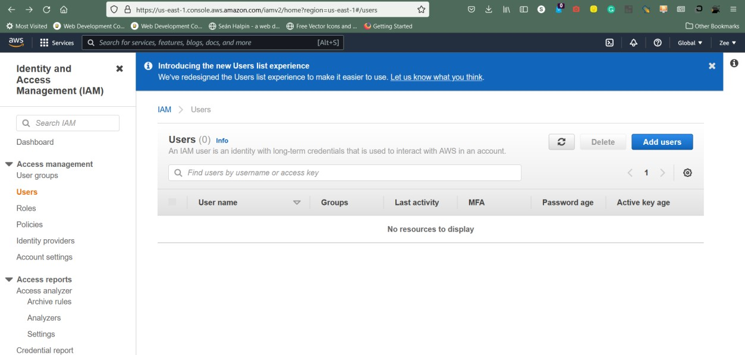

1. **Add User Name**

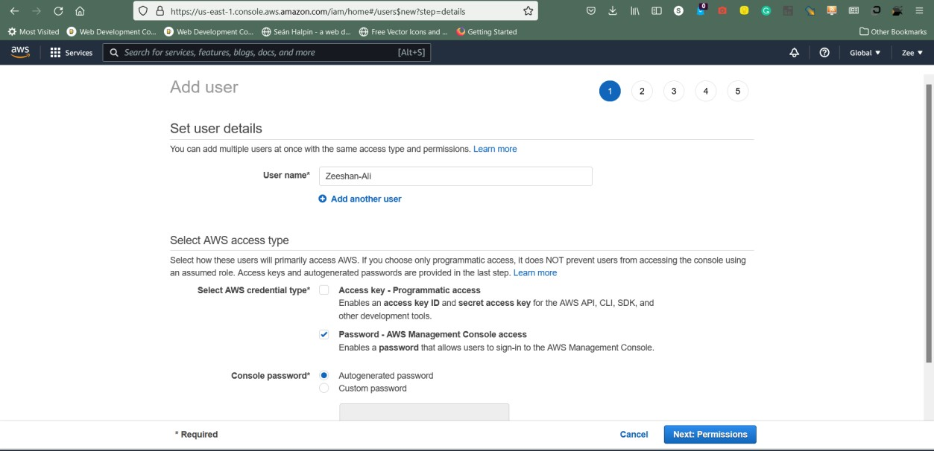

1. **Set Permissions**

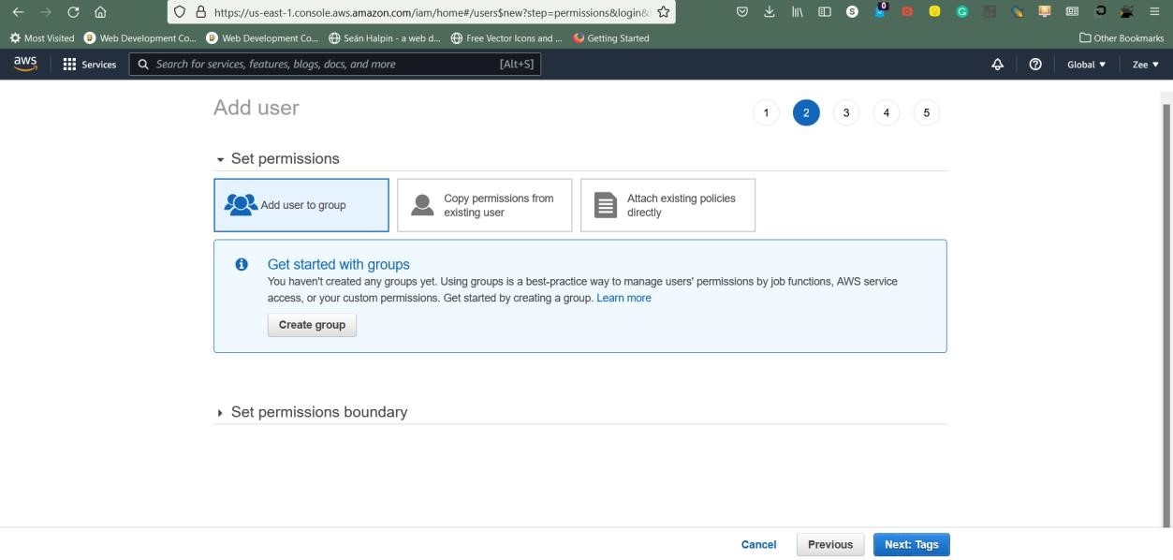

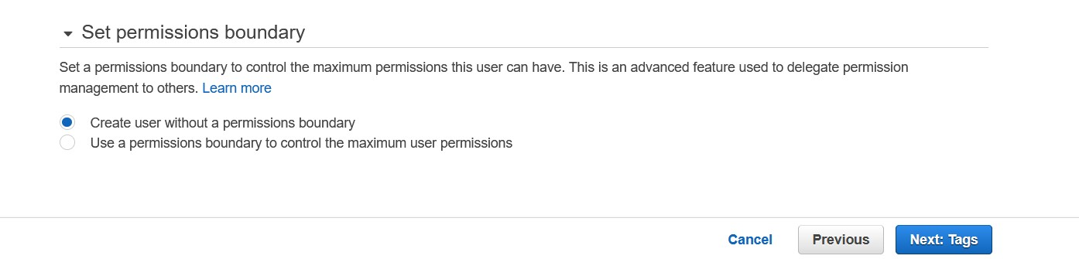

1. **Add Tags**

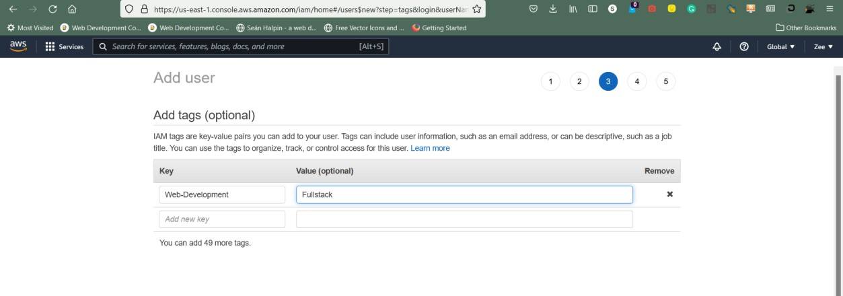

1. **Click-On Create User**

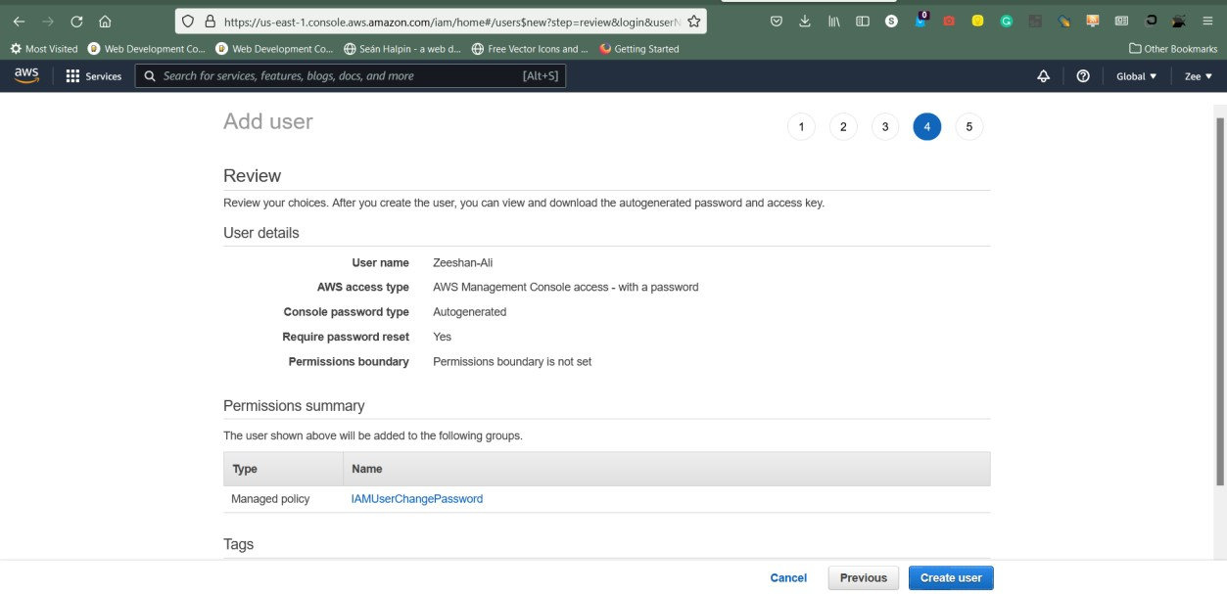

1. **User has been created successfully**

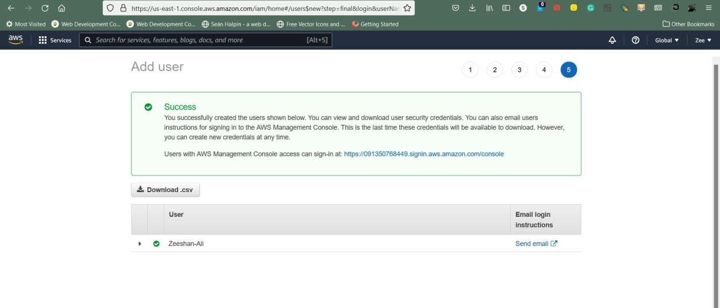

**C) User Groups**

**Steps:**

1. **Click-On Create Groups.**

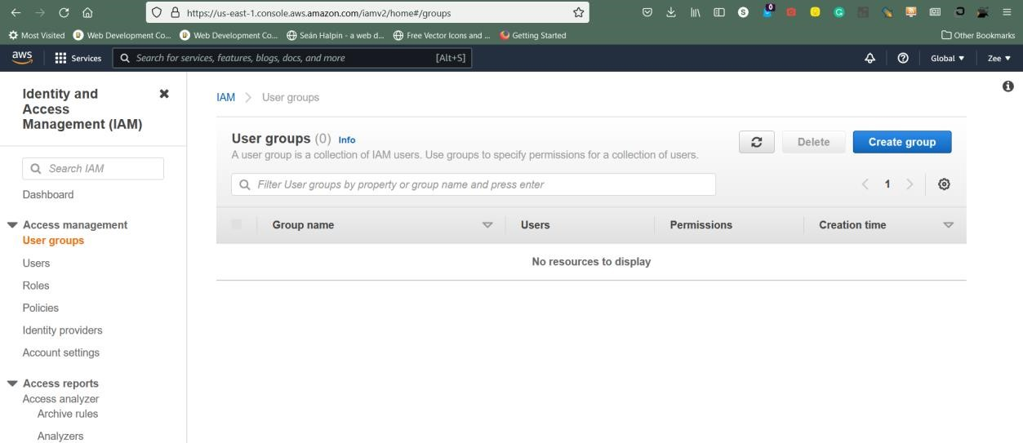

1. **Assign names to the group.**

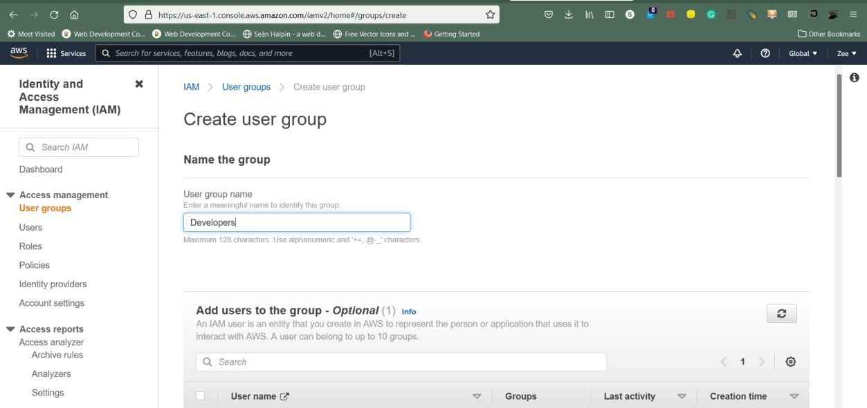

1. **Add Users to the group.**

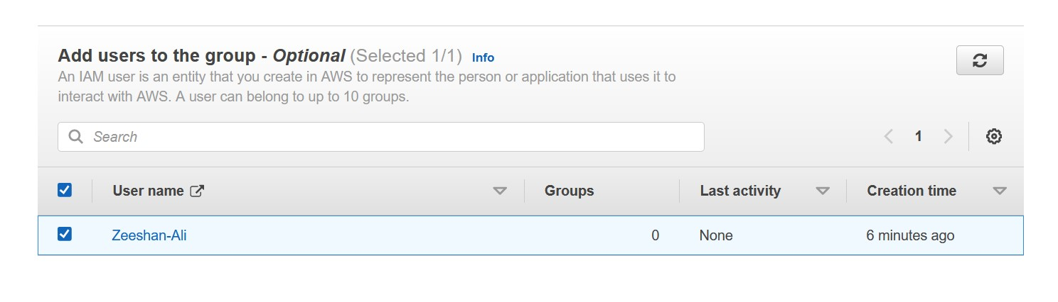

1. **Attach Permissions to the group.**
2. **Click-On create group.**

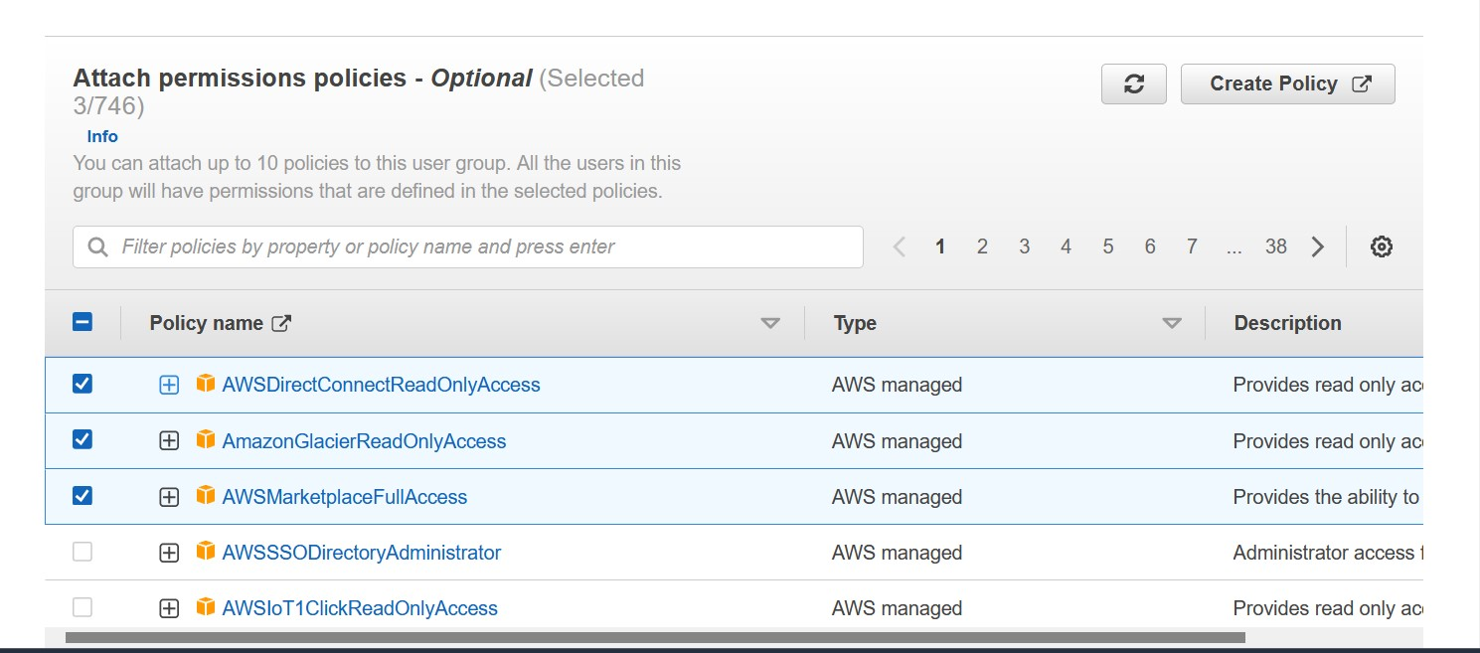

1. **User group generated.**

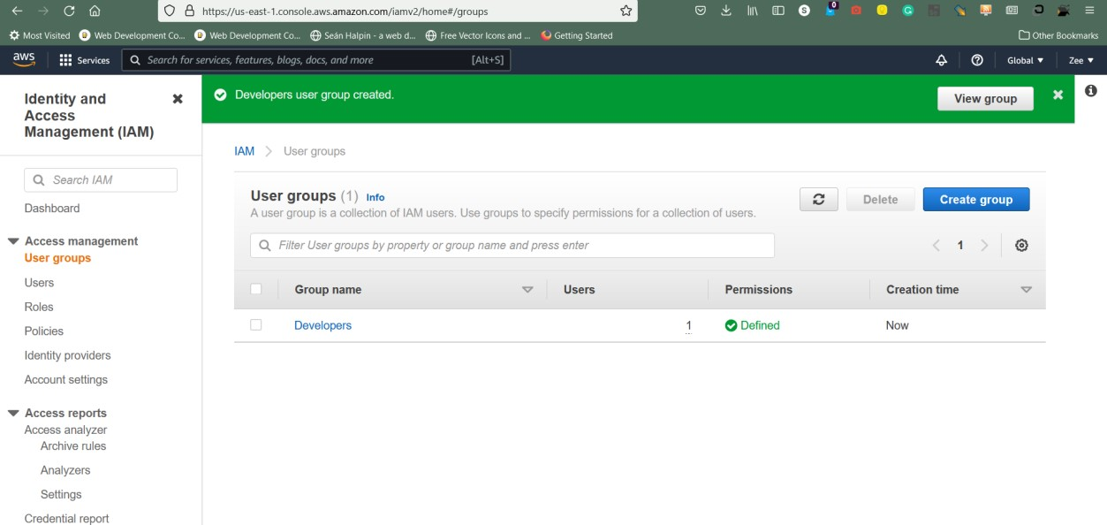

**D) Create Policies**

**Steps:**

1. **Click-On user you want to update policies for**

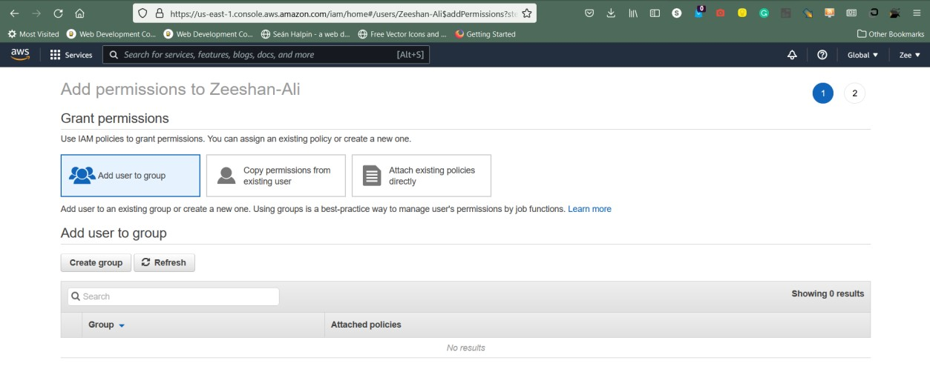

1. **Create a Group**

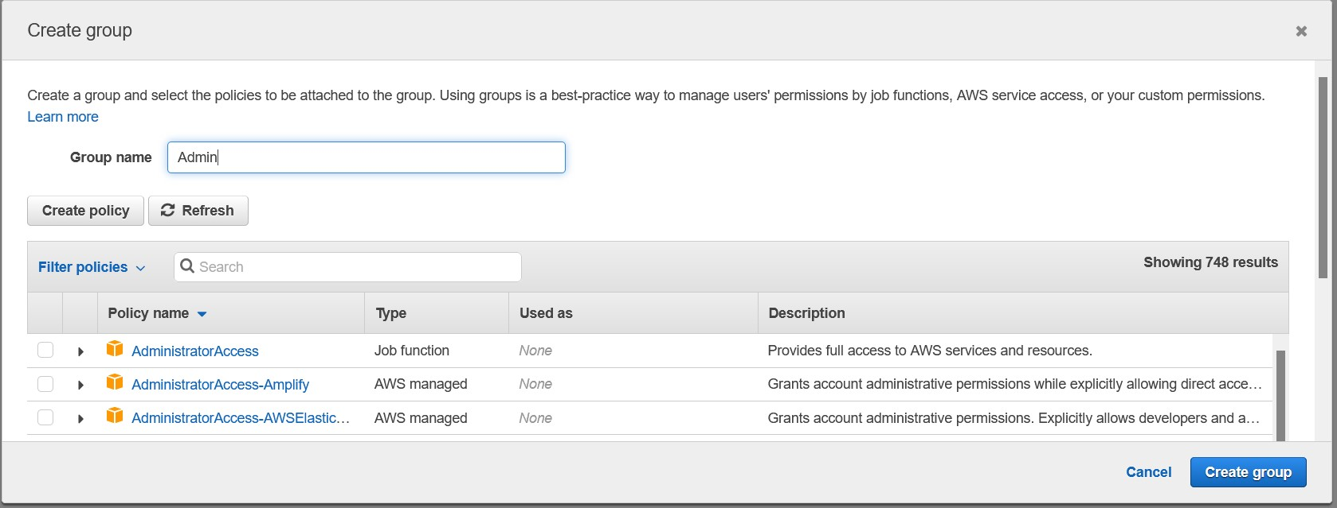

1. **Add policies for the group.**

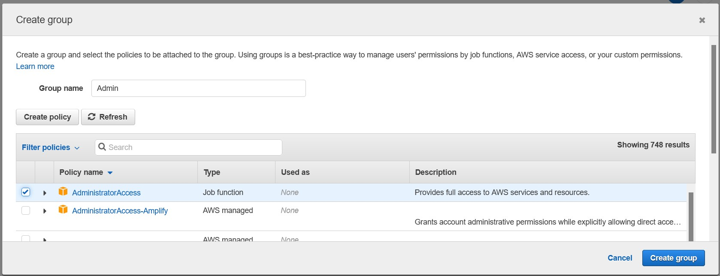

1. **Click On Generate Policy.**

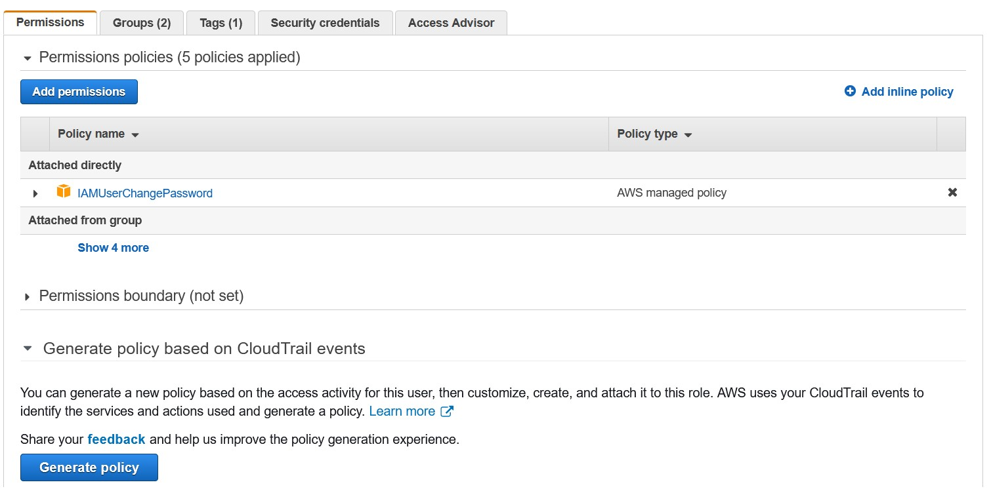

**Conclusion:** IAM operation executed successfully.

**Experiment no – 08**

**Aim: Demonstrates how to make basic requests to Amazon DynamoDB**

**including:**

* **how to add items to a table.**
* **how to get items from a table.**
* **how to query items on a table.**
* **how to scan items from a table using a filter expression.**
* **how to update items on a table.**
* **how to delete a table.**

**Steps:**

1. **Create table**

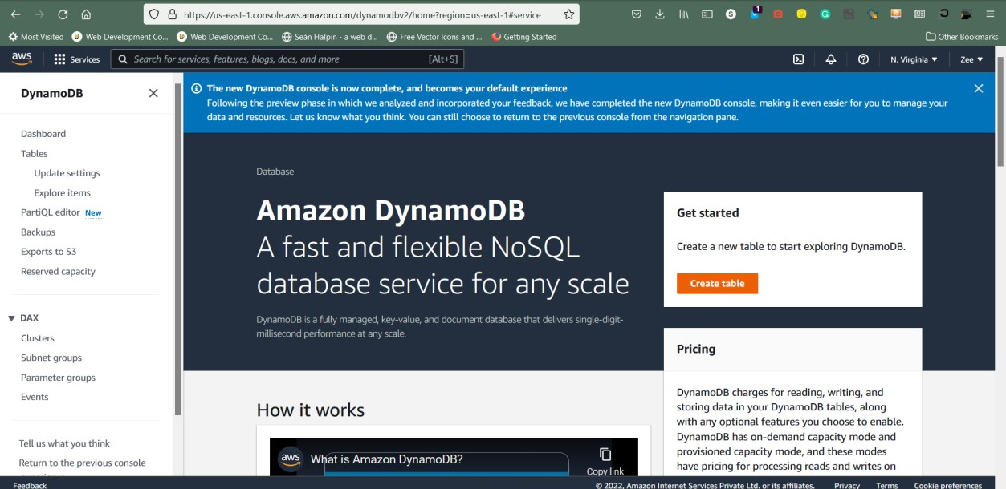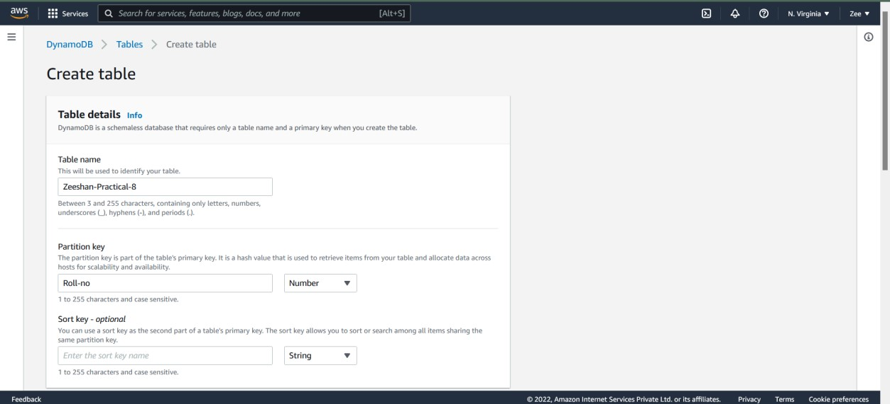

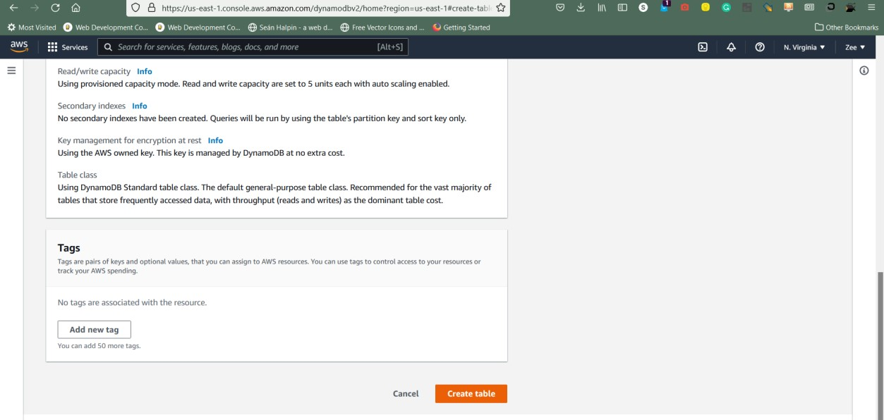

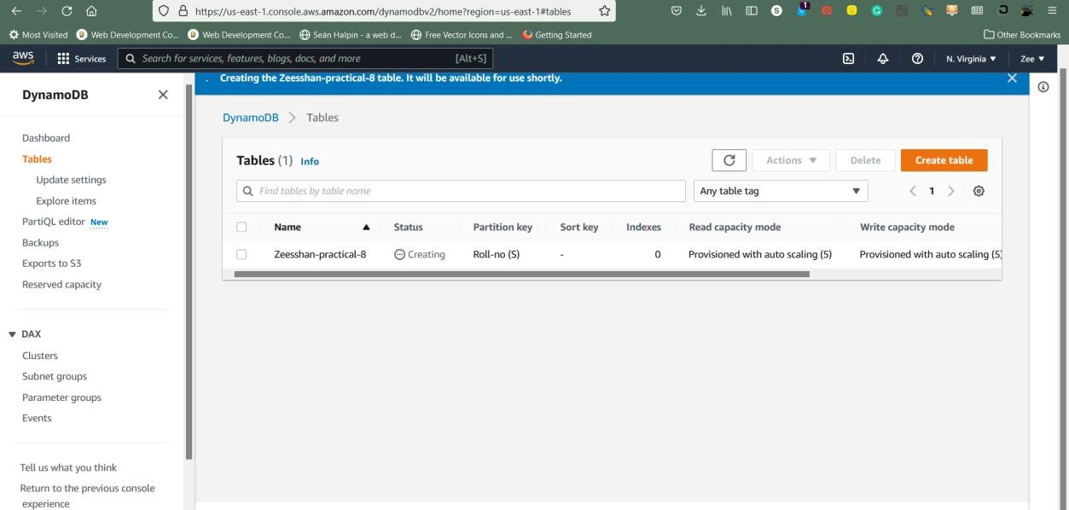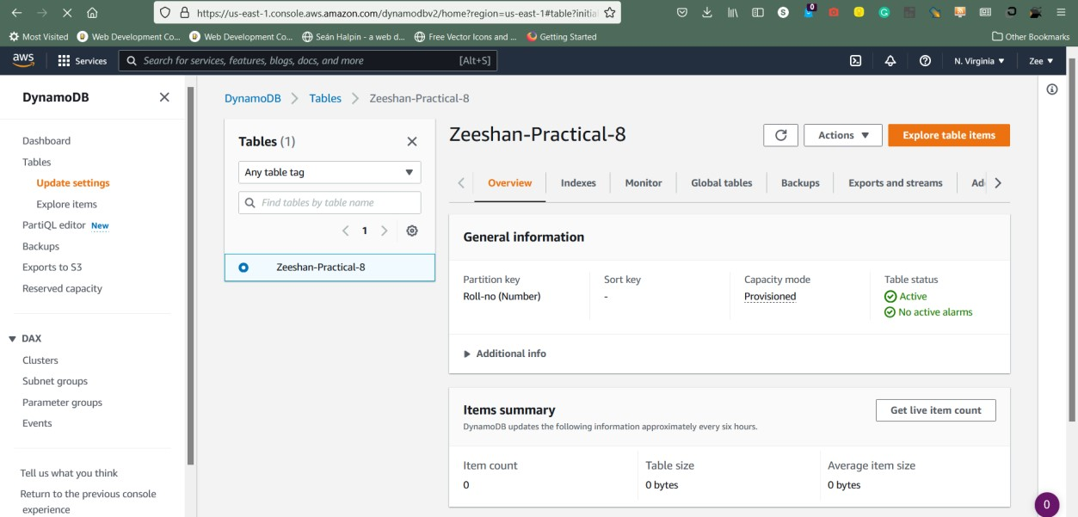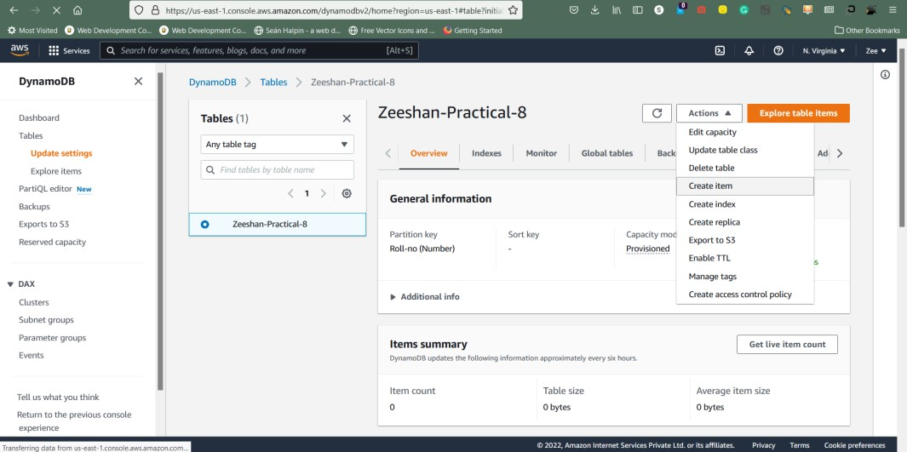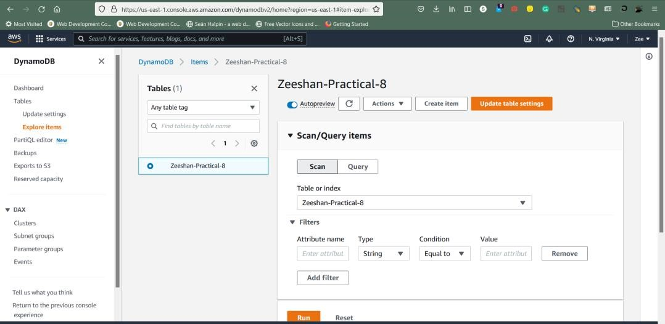

1. **Create Item**

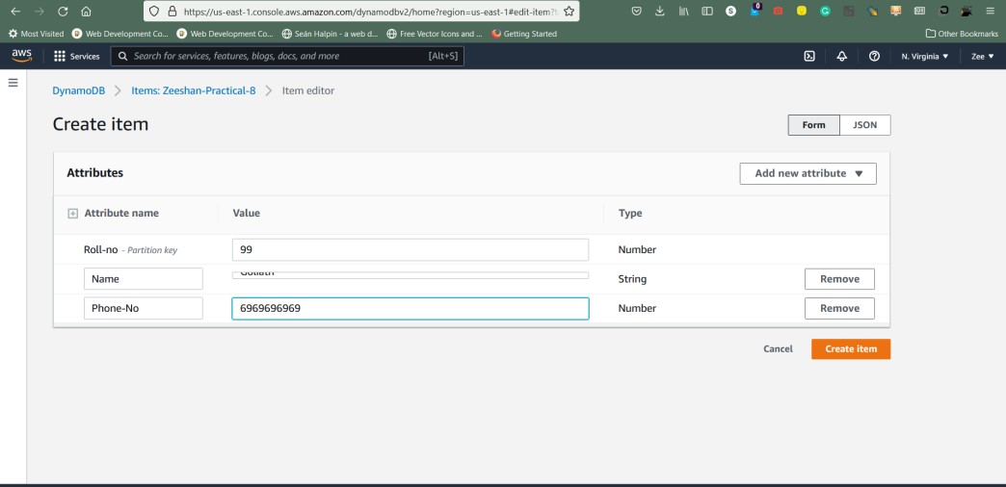

1. **Scan Items.**

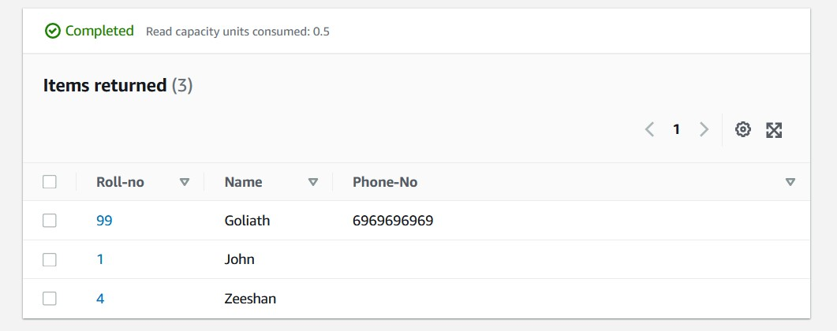

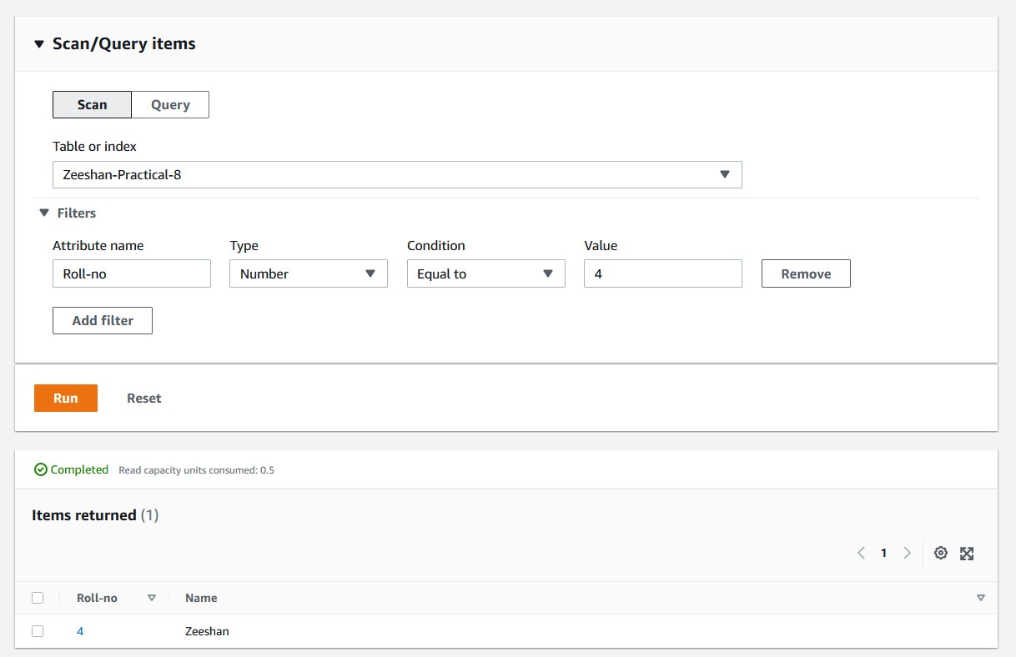

1. **Query Items.**

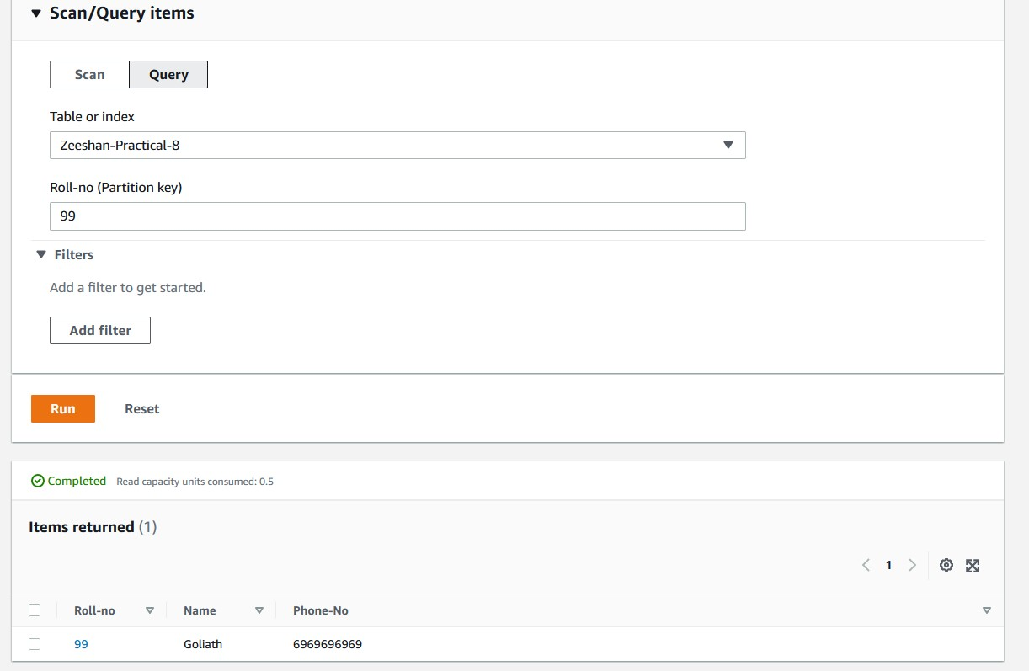

1. **Delete table**

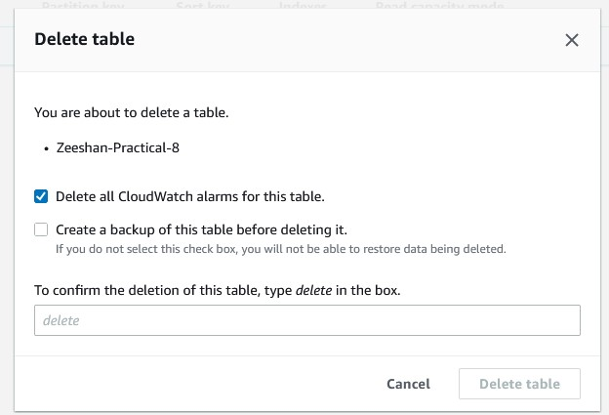

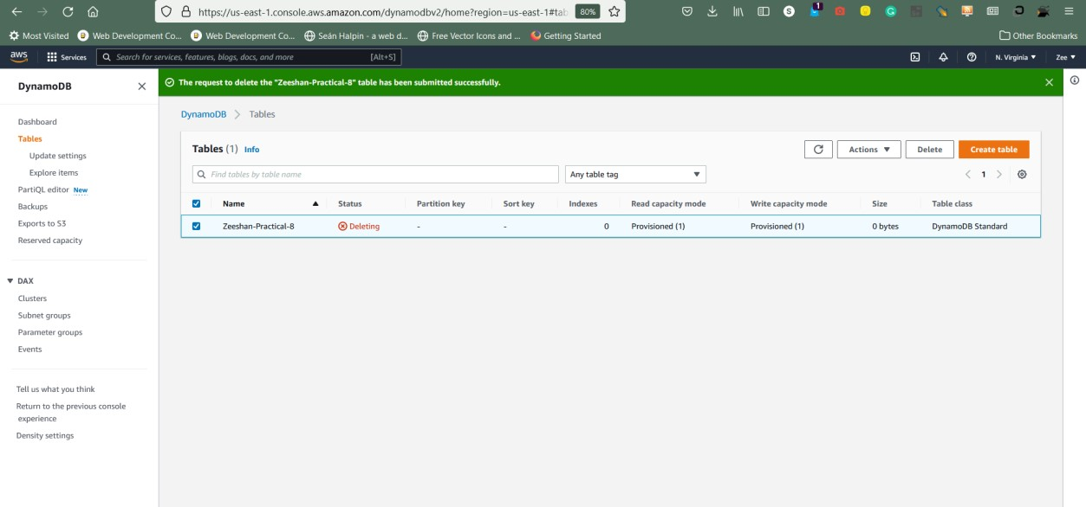

**Conclusion:** IAM operation executed successfully.

**Experiment no – 08**

**Aim: Demonstrates how to make basic requests to Amazon DynamoDB**

**including:**

* **how to add items to a table.**
* **how to get items from a table.**
* **how to query items on a table.**
* **how to scan items from a table using a filter expression.**
* **how to update items on a table.**
* **how to delete a table.**

**Steps:**

1. **Create table**







1. **Create Item**



1. **Scan Items.**





1. **Query Items.**



1. **Delete table**





**Conclusion:** IAM operation executed successfully.